George Singleton

July 5, 1909 – January 31, 2007

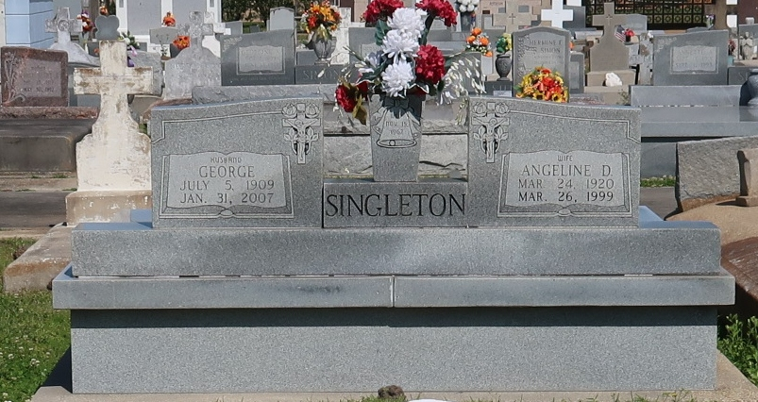

AUGUSTA, Ga. - Mr. George Singleton of Milledgeville Road entered into rest Wednesday, January 31, 2007 at the Blair House Nursing Home. Funeral service will be held Saturday, February 10, 2007 at 11 a.m. at Williams Funeral Home Chapel with Rev. Annette Williams officiating. The remains will be conveyed to Davis Mortuary Service, Gretna, La. for service and burial. Williams Funeral Home, 1765 Martin Luther King, Jr. Blvd.

Published by The Augusta Chronicle on Feb. 10, 2007.