Alton Moore Smith

June 9, 1933 – October 4, 2010

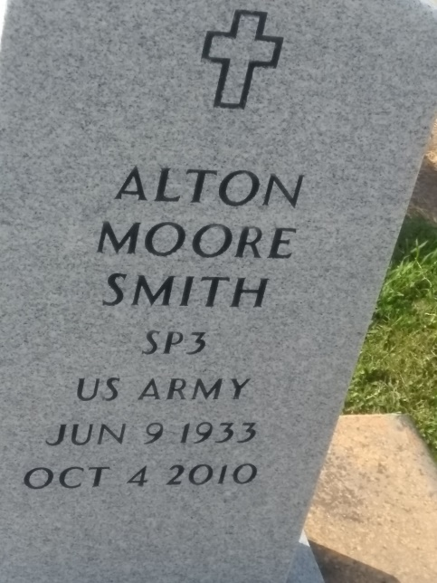

Photo by TMB

Alton Moore Smith, Sr., passed away on October 4, 2012 at the age of 79 years old. Son of the late Rev. John and Lillian Smith of Kentwood, La. Father of Renea (William, Sr.) Warren and Alton (Janet) Smith, Jr. Grandfather of William Warren, Jr. and Lillian Warren. Brother-in-law of Ella Mae and Bernadine Garrett. Also survived by a host of nieces, nephews, other relatives and friends. Family and friends are invited to attend a Mass of Christian burial at Our Lady of Peace Catholic Church, 13281 La. Highway 644, Vacherie, La. on Wednesday, October 10, 2012 for11:00 a.m. Father Michael Miceli will be Officiating. Interment will be at Our Lady of Peace Catholic Church Cemetery. Visitation will be from 9:00 a.m. until time of service. Funeral entrusted to The Baloney Funeral Home, LLC., 399 Earl Baloney Street, Garyville, La., 985-535-2540. Condolences can be expressed at [www.baloneyfuneralhome.com](http://www.baloneyfuneralhome.com/)

The Times-Picayune, New Orleans, LA

October 5-7, 2012.