Mary Delores (Bartholomew) Smith

May 19, 1943 – January 30, 2002

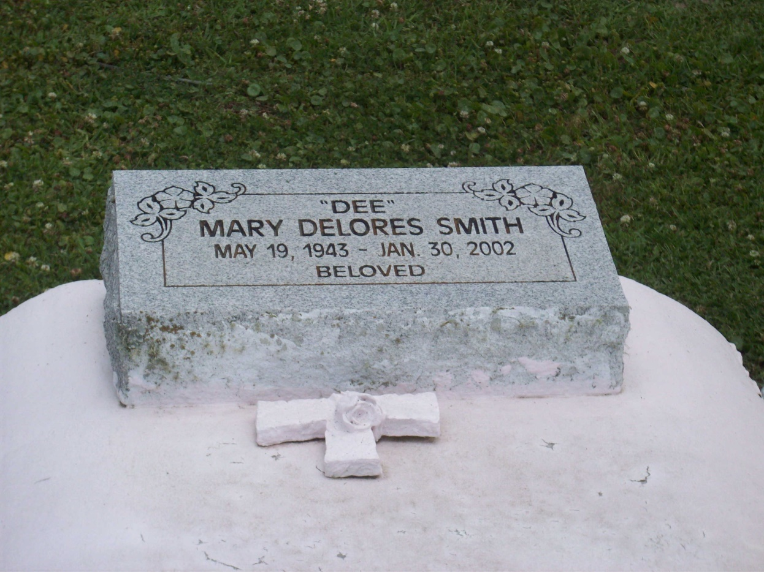

Photo by TMB

Mary Delores Bartholomew Smith, a private home patient care attendant, died Wednesday of leukemia at University Hospital. She was 58. Mrs. Smith was born in Vacherie and lived in Baton Rouge. She graduated from Magnolia High School.

Survivors include her mother, Viola Lewis Bartholomew; a son, Shawn Daniel Smith; three brothers, Edward, Nelson and Charles Bartholomew; and a sister, Louise Bartholomew.

A funeral will be held Monday at 11 a.m. at Our Lady of Peace Catholic Church, Vacherie. Visitation will begin at 9 a.m. Burial will be in Our Lady of Peace Cemetery. D.W. Rhodes Funeral Home is in charge of arrangements.

Times-Picayune, The (New Orleans, LA) - Saturday, February 2, 2002

Contributed by Jane Edson