Alice (Gros) Steib

February 5, 1935 – March 21, 2016

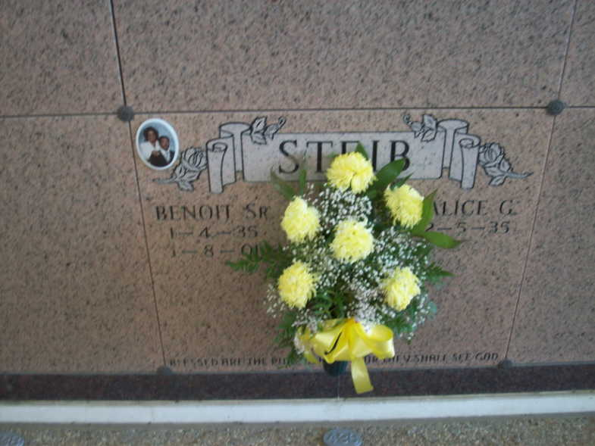

Photo by TMB

Alice Gros Steib at the age of 81 entered her eternal home surrounded by loves ones.   
 She leaves to cherish her memories with her children; Grant Christopher (Angelina) Steib, Vanessa (Percy) Gasery, Cassandra (Anthony) Bailey and Benoit Steib Jr. of Vacherie. She was a devoted grandmother to seven grandchildren and six great grandchildren. She is also survived by her sisters, brother in laws and sister in laws LeBoria Burrell Daisy (Ridgely) Mitchell, Rose (Teddy) Boudoin, Paul (Emma) Steib, Russell (Linda) Steib, Lazard (Sharon) Steib, Jacqueline Gros and Imelda Gros.   
 Proceeded in death by her husband Benoit Steib Sr.; grandson Rashaud Benoit Gasery; parents; Olyampe and Naulest Gros Sr.; sibilings Ollie Narcisse, Edmond Gros, Francois Gros, Olivia Morton, Naluest Gros, Gladys Narcisse, Reginia Steib, Nazie Gros and Raymond Gros and nieces, nephews, and cousins.  
 She was the Godmother of Rose Jessie, Wanda Gros, Ashley Shephard, Jonathan Dumas and Bruce Wood.  
 Visitation will be held on Monday, March 28, 2016 from 8:00 am to 11:00 am at Our Lady of Peace Catholic Church in Vacherie, LA. A Mass of Christian Burial will be celebrated at 11:00 am at the church followed by interment in the church cemetery.  
 Arrangements entrusted to Thibodaux Funeral Home of Thibodaux, LA.

Unknown source