Alice (Isom) Steib

January 1, 1925 – February 18, 2009

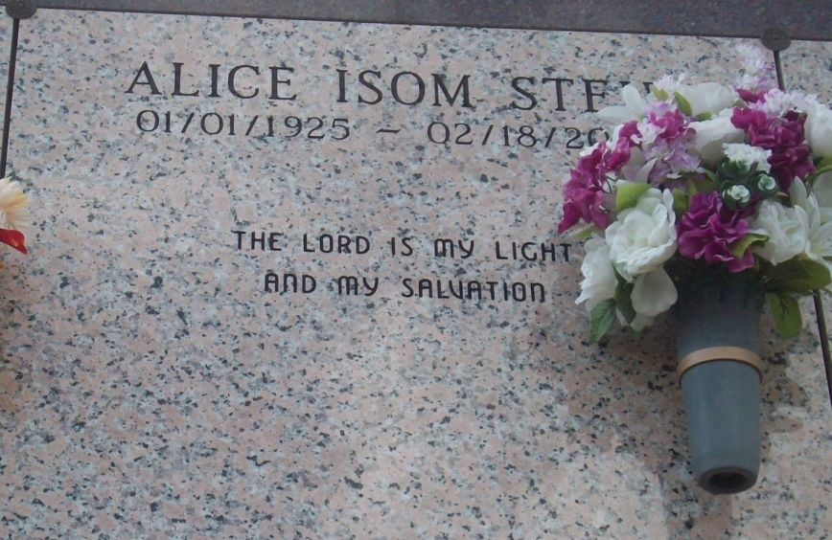

Photo by TMB

ALICE ISOM STEIB: a retired St. James Parish School Board Food Service employee, died Wednesday Feb. 18, 2009 at Audubon Guest Home in Thibodaux, LA. She was 84, a native and resident of Vacherie, LA.

Visiting at Our Lady of Peace Catholic Church, South Vacherie, on Saturday, Feb. 28, from 9 a.m. until religious service at 11 a.m. Burial in the church cemetery.

Survived by two daughters and and sons-in-law, spouses, Laura S. and Henry Mitchell, Jr. and Ramona S. and Karl Mitchell, Sr.; three sisters and two brothers-in-law, Josephine I. Kennedy, Ethel and Oregon Howard, Lottie and Peter Mitchell; two brothers and and a sister-in-law, Joseph C. Isom and Norris and Evelyn Isom; six grandchildren, four sisters-in-law; a brother-in-law and a host of nieces, nephews, other relatives and friends. Preceded in death by her husband, Paul Steib; parents, John and Laura James Isom; two brothers, two sisters-in-law and four brothers-in-law.

In lieu of flowers, the family requests that donations in her memory be made to the Alzheimer’s Association. Arrangements by Williams & Southall Funeral Home of Napoleonville, (985) 369-7231.

Advocate (The), Baton Rouge, LA; February 27, 2015