Benoit Joseph Steib Sr.

January 4, 1935 – January 8, 2001

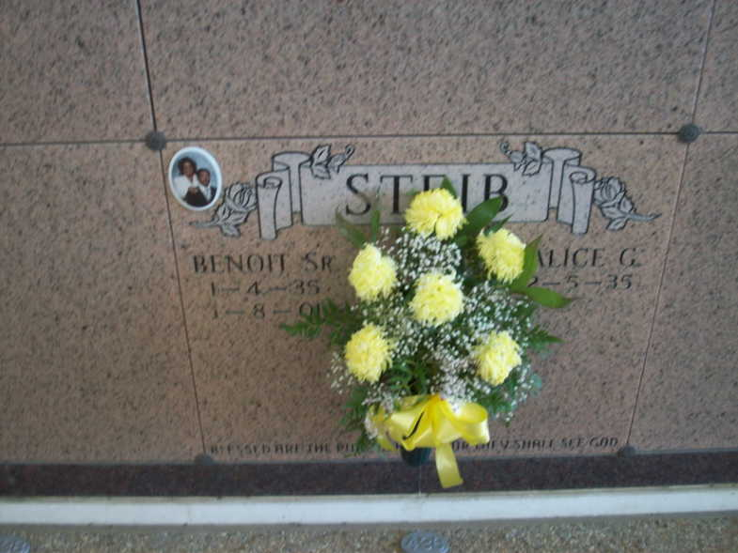

Photo by TMB

Benoit 'Ben' Joseph Steib, Sr., age 66, born January 4, 1935, died January 8, 2001 at 9:21 AM. A native and resident of Vacherie, LA. Survived by: Wife, Alice Gros Steib, and sons: Grant Christopher and Benoit Steib, Jr. Daughters: Vanessa S. Gasery and Cassandra S. Bailey, Brothers: Russell, Paul and Lazard Steib, Jr. and Sisters: Madeline Steib and Rowena S. Wallace. Also survived by 5 grandchildren and 1 great-grandchild. Preceded in death by: Parents: Lazard (Sr) and Hilda Jones Steib and Sisters Amanda S. Oubre and Melvina S. Simmons. Visitation: 8 AM until Funeral Time on Thursday, January 11, 2001 at Our Lady of Peace in Vacherie, La. Mass of Christian Burial on Thursday , January 11, 2001 at 11 AM at Our Lady of Peace in Vacherie, La. Interment in Our Lady of Peace Cemetery in Vacherie, La. Landry's Funeral Home, Inc., in charge of arrangements.

Times-Picayune, The (New Orleans, LA) - Wednesday, January 10, 2001

Contributed by Jane Edson