Ethel (Poirrier) Steib

July 18, 1920 – November 17, 2003

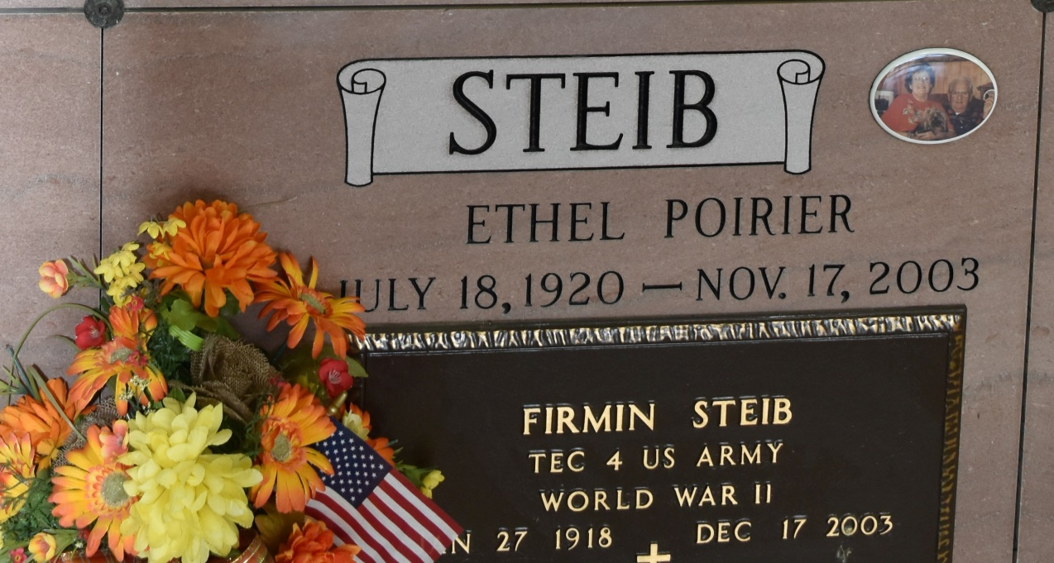

Photo by TMB

A loving wife, mother, grandmother and great-grandmother, Ethel Poirier Steib, died on Monday, November 17, 2003 at 5:45 a.m. at her daughter's home in Vacherie, LA. Her smiling face will always be remembered. She was 83 years old and was born in St. James, LA and a resident of Vacherie, LA.

Survived by: her husband, Firmin Steib; a daughter, Judy Folse and husband, Stanley ""Dip'' Folse; a son, Ronald Steib and wife, DeLane all of Vacherie, LA; six grandchildren: Kim Adams and husband, Patrick Adams, Timmy Folse and wife, Melissa Folse, Mary Beth Scorsone and her husband, Michael Scoresone all of Vacherie, LA, Rhonda Green and husband, Joel Green of Baton Rouge, LA, Rebecca Saunders and husband, Brian Saunders of New Orleans, LA, and Renee' Steib of Baton Rouge, LA; seven great-grandchildren: Alex and Whitney Adams, Bradley and Collin Folse, Katherine, Caroline and Elizabeth Scorsone.

Preceded in death by: her parents: Emile and Aurelie Laurent Poirrier; sisters: Lena Tauzin, Lelia Morales, Ada Morales and Hazel Cazes; and brother, Willis Poirrier.

Mrs. Steib was a charter member of the Catholic Daughters of America's Court of St. Philip 1504 and a perpetual adorer of Our Lady of Peace Church.

Visitation will be at St. Philip Church from 8:30 a.m. until funeral time with Mass at 11:00 a.m. on Wednesday, November 19, 2003. Interment at Our Lady of Peace Cemetery, Vacherie, LA. A service will be conducted by the Catholic Daughter Court of St. Philip, 1504 at the Church for 9:00 a.m. Followed by the Recitation of the Rosary. Pallbearers will be: Patrick Adams, Timmy Folse, Michael Scorsone, Joel Green, Brian Saunders and Willis Poirrier, Jr. ROSE-LYNN FUNERAL HOME in charge of arrangements.

The Times-Picayune, New Orleans, LA

November 18, 2003