Hamilton Steib Sr.
1944 – July 24, 2024

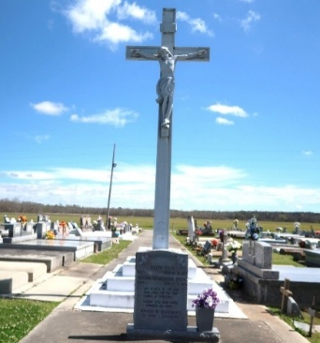

Hamilton Steib Sr., a native and resident of Vacherie, passed away peacefully at his residence on Wednesday, July 24, 2024. He was 80. Visiting at Our Lady of Peace Catholic Church in Vacherie, on Saturday, August 10, 2024 from 9:00 a.m. until Mass of Christian Burial at 10:30 a.m. Interment in church cemetery.
Survived by his wife, Doris Long Steib. His daughters, Michele (Allen) Dennis, Gaynell Steib, and Tonga Pyles. His son, Hamilton Steib, Jr. Sisters, Rita (Robert) Charles and Christine (Marlis) Fletcher. Brothers, Hilton (Ann) Steib, Jr., Vincent (Emily) Steib, Sr., Joseph Raymond Steib, Sr. and Joseph Preston (Bridgette) Steib, Sr. Brothers-in-law, Joseph (Rosemarie) Long, Sr. and Alton (Mary Alice) Long, Sr. Also survived by 17 grandchildren, 16 great-grandchildren, numerous nieces, nephews, cousins, godchildren, other relatives and friends.
Preceded in death by his parents, Hilton Steib, Sr. and Wilborine Dumas Steib. His daughter and son-in-law, Latricia Woods and husband, Jacob. Sisters-in-law, Elaine Steib, Alice Diggs, Rosalie Hogan, and Georgiana and Genevia Long. Brothers-in-law, Willie Hogan, Guilliard Long, Sr. and Sampson Long, Jr. His father and mother-in-law, Sampson Long, Sr. and Mary Luke Long.
Brazier-Watson Funeral Home in charge of arrangements.

The Advocate, Baton Rouge, Louisiana
Aug. 8 to Aug. 9, 2024

