Marie Elaine (Dumas) Steib
August 22, 1940 – October 3, 2025

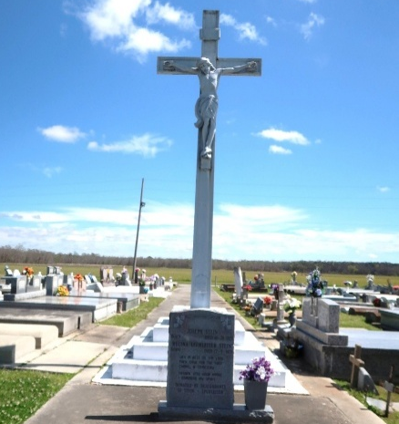

The Lord welcomed home His faithful servant, Marie Elaine Steib, on Friday, October 3, 2025, at the age of 85. She was the beloved daughter of the late Lionel and Mary Favaroth Dumas. Marie lived a life marked by faith, generosity, and love of community. She was best known for her bread pudding, a family recipe that became her signature dish and a source of comfort and joy to all who shared it. For many years, she worked at Sears and lovingly cooked meals for the Priest at Our Lady of Peace Catholic Church, a service she embraced as part of her devotion to God. Beyond the church, she was a caregiver for young children and the elderly, and an active supporter of community gatherings and a familiar presence at the Council on Aging, where her kindness and hospitality touched the lives of many. Her passions were her family, her church, and the people of her community. She believed deeply in the power of fellowship and left behind a legacy of faith, service, and love that will be cherished for generations.
Mourning her departure while celebrating her life is her devoted husband of 64 years, Joseph Eloy Steib; children, Belinda Hilaire, Terrance Steib (Martha), Terry Steib (LaTasha), and Sonya Lumar (Jim); grandchildren, Shandell Harry, Randy Hilaire, Jr. (Shayla), Desi Steib, Ceari Lewis (Terrence), Terry Goudy, Brittany Hilaire (Latrell), Jamison Lumar (Jala), and Jamin Lumar (Sierra); 10 great-grandchildren; 6 Godchildren; and a host of nieces, nephews, extended family, and friends.
She was preceded in death by her parents, Lionel and Mary Favaroth Dumas; siblings, Joshua Dumas (Mary) and Lucille Harry (Sylvain); grandson, Jason Steib, Sr.; great-grandson, Jairen Cole; and other loved ones who now rejoice with her in Heaven.
Visitation will be held on Saturday, October 11, 2025, at New Hope International Family Center, located at 24190 Highway 20, Vacherie, LA 70090, from 8 AM to 10 AM. A Celebration of Life Service will follow at the same location, beginning at 10 AM. Interment will be at Our Lady of Peace Catholic Cemetery.

Treasures of Life Funeral Services, Gramercy, Louisiana
October 14, 2025

