Nelson “Tune” Steib, Sr.

September 1, 1916 – August 28, 2003

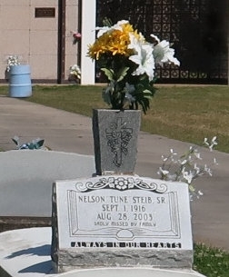

Nelson ''Tune'' Steib, Sr. on Thursday, August 28, 2003 at Thibodaux Regional Medical Center. Husband of the late Rosemary Jeffery Steib. Son of the late Sylvester and Amy Steib. Father of Ruby (Sidney) Weber, Diana (Grover) Singleton, Cynthia (Alfred) Joseph, Mary Theresa (Phillip) Hughes all of Marrero, LA., Mary Alice (Alton) Long of Lutcher, LA., Donna (Charles) Love of Gonzales, LA., Nadine (Herman) Lewis and Darlene Steib Mayho, Ronald (Celestine), Alvin (Delores), Nelson, Jr. (Rita), Ronnie (Wanda) Steib all of Vacherie, LA., Royally Steib of LaPlace, LA., James (Sheila) Steib of Colorado Springs Colo., and Michael (Alice) Steib of Hahnville, LA.; Brother of Pierre and Sylvester Steib, Jr. and Emma Narcisse of Vacherie, LA., Clifford Steib, Marina and Amy Saul of Marrero, LA and Florence Jeffery of Thibodaux, LA., and the late Floretta Dumas, Lauvertha Gros, Louvana Lemieux, Florian, Calvin and Hilton Steib, Sr.; also survived by and uncle and aunt, Mr. and Mrs. Florian Oubre of Vacherie, LA., 42 grandchildren, 48 great-grandchildren and a host of brothers and sisters-in-law, nieces, nephews other relatives and friends. A native and resident of Vacherie, LA. Age 86 years.

Relatives and friends of the family, Pastor and Parishioners of St. Phillip Catholic Church, Our Lady of Peace Catholic Church, Good Children's Benevolent Society are invited to attend the Mass of Christian Burial on Tuesday, September 2, 2003 at 11:00AM from St. Phillip Catholic Church in Vacherie, LA. Interment in Our Lady of Peace Catholic Church Cemetery. Visitation after 8:00AM followed by Rosary at 9:00AM. Williams & Southall Funeral Home, Napoleonville, in charge of arrangements.

The Times-Picayune, New Orleans

September 1, 2003