Reginald Charles Steib
August 12, 1958 – September 17, 2018

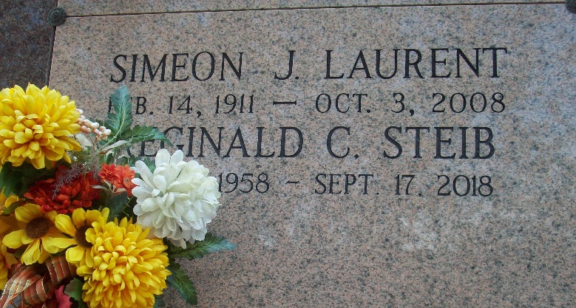
Photo by TMB

Reginald Charles "Reggie" Steib. departed this earthly life on Monday, September 17, 2018 at the age of 60 surrounded by his family at Our Lady of the Lake Regional Medical Center-Baton Rouge, La. Reggie was born on August 12, 1958. Reggie was the oldest of seven children born to the union of Russell and Linda Steib. He was baptized at Our Lady of Peace Catholic Church on August 24, 1958 by Rev. George Barbier.
He leaves to cherish his memories his father and mother, Russell and Linda Laurent Steib, Sisters- Valerie Batiste, Yvette (Samuel) Joseph, Sherrylynn Charles; Brothers Adrian (Paulette) Steib, Demetrius Steib; several aunts, uncles, nieces, nephews, godchildren, cousins and friends. Preceded in death by his Grandparents, Lazard and Hilda Steib; Simeon and Dorothy Laurent; brother Erwin Steib, brother-in-law Earl Batiste. Reggie was a native and resident of Vacherie, La.
Relatives, friends, priest, and parishioners of Our Lady of Peace Catholic Church, Vacherie, LA and all neighboring churches, are invited to attend the Funeral Mass at Our Lady of Peace Catholic Church 13281 Highway 644 Vacherie, La on Saturday, September 22, 2018 at 11:00AM. Father Brad Doyle celebrant. Visitation at the church after 9:00am Rosary at 9:30 am. Burial will be private.

Treasures of Life Funeral Services, Gramercy, Louisiana

