Gerald Stein

September 10, 1949 – September 8, 2019

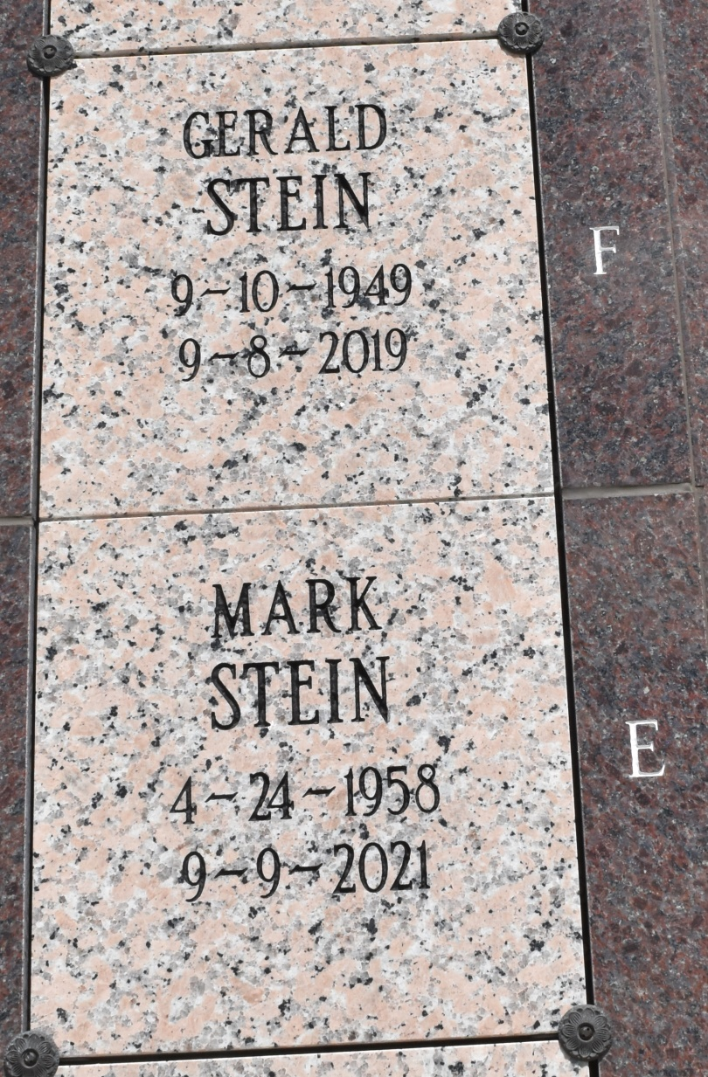

Gerald Stein, 69, a native and resident of Vacherie, Louisiana passed away on Sunday, September 8, 2019.

He is survived by his siblings, Drew Stein, Anthony Stein, Clare Himel, Edmond Stein, Stephen Stein, Jane Duhe, Mark Stein, Patrick Stein, Roland Stein, and Gary Stein. He was preceded in death by his parents, Leonce Stein and Marguerite Webre Stein; brothers, Huey Stein, Bruno Stein, Guy Stein, Ronald Stein, and Claude Stein; and sister, Margaret Stein.

Online condolences can be given at www.landrysfuneralhome.com Landry's Funeral Home, Inc. is in charge of arrangements.

Tributearchive.com