Alvin Francis Webre

December 24, 1900 – February 1, 1960

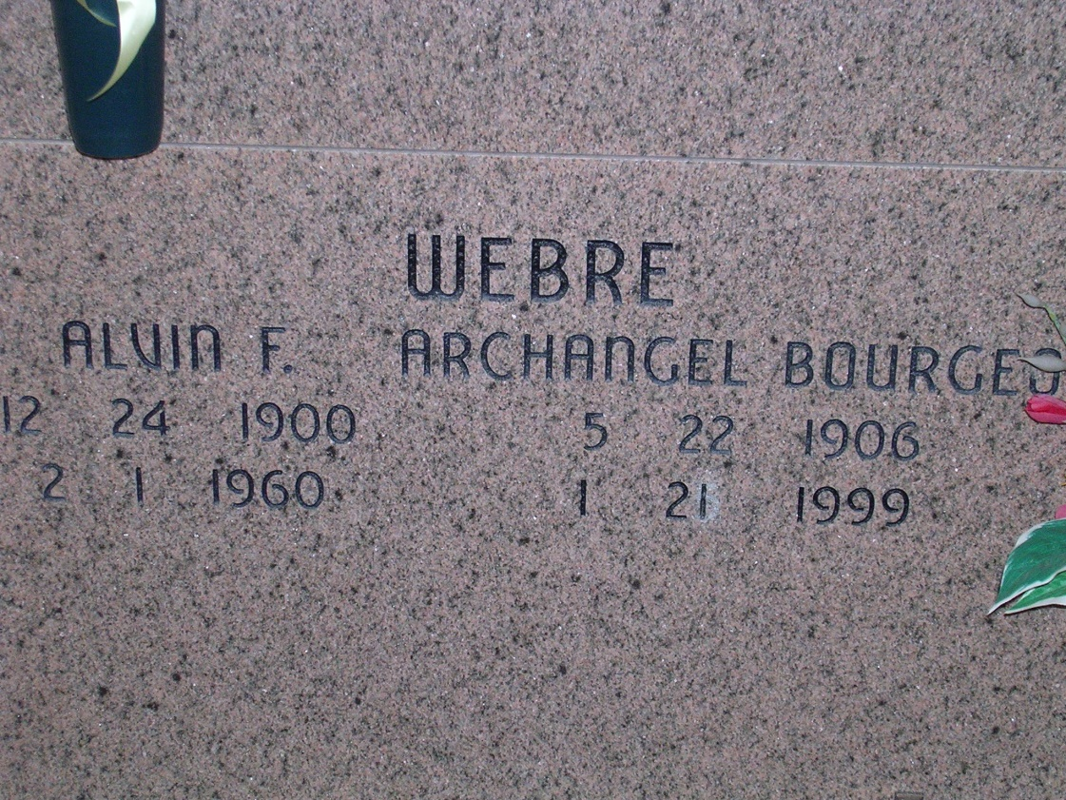

Photo by rrcar

Name: Alvin Francis Webre  
Titles and Terms:   
Event Type: Death  
Event Date: 01 Feb 1960  
Event Place: New Orleans, Orleans, Louisiana, United States  
Gender: Male  
Age:   
Birth Date: 24 Dec 1900  
Birth Year (Estimated):   
Father's Name: John C Webre  
Father's Titles and Terms:   
Mother's Name: Margaret Webre  
Mother's Titles and Terms:   
Parent Name:   
Spouse's Name: Archangel Bourgeois  
Spouse's Titles and Terms: