Esther Mae (Harry) Williams

May 10, 1940 – August 21, 1999

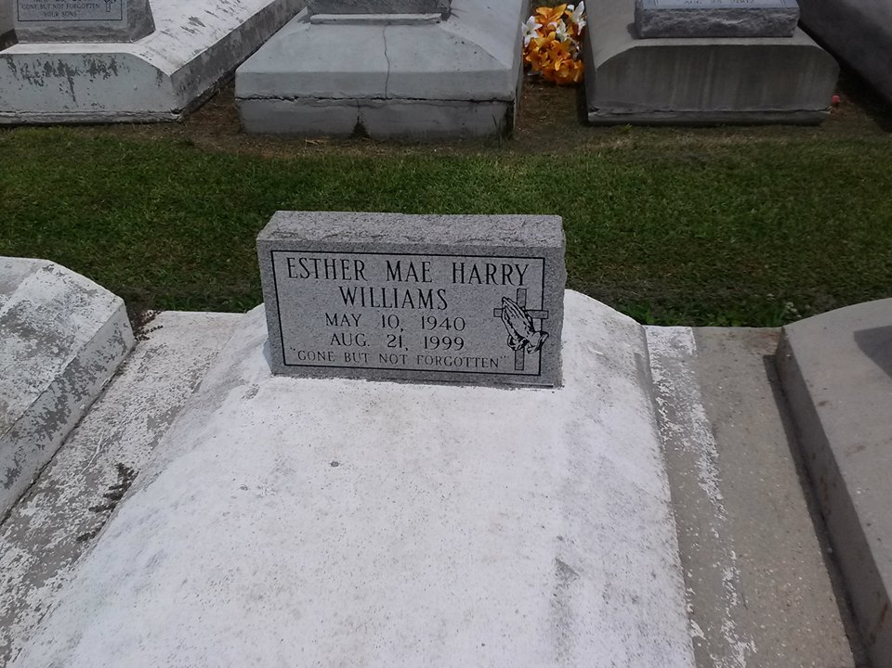

Photo by TMB

Esther Mae Harry Williams, a custodian for the Jefferson Parish school system, died Saturday August 21, 1999 of cancer at her home. She was 59. Mrs. Williams was born in St. James Parish and lived in Marrero. Survivors include three sons, Darnell, DeMond and Tommie Lee Williams Jr.; five daughters, Patricia W. Grogen, Cynthia, Tammy, Dionne and Tara Williams; two brothers, Milton Harry Sr. and Herbert Harry Sr.; two sisters, Anita and Eva Batiste; and three grandchildren.

Unknown source