Virginia (Melancon) Williams

January 5, 1936 – August 5, 2008

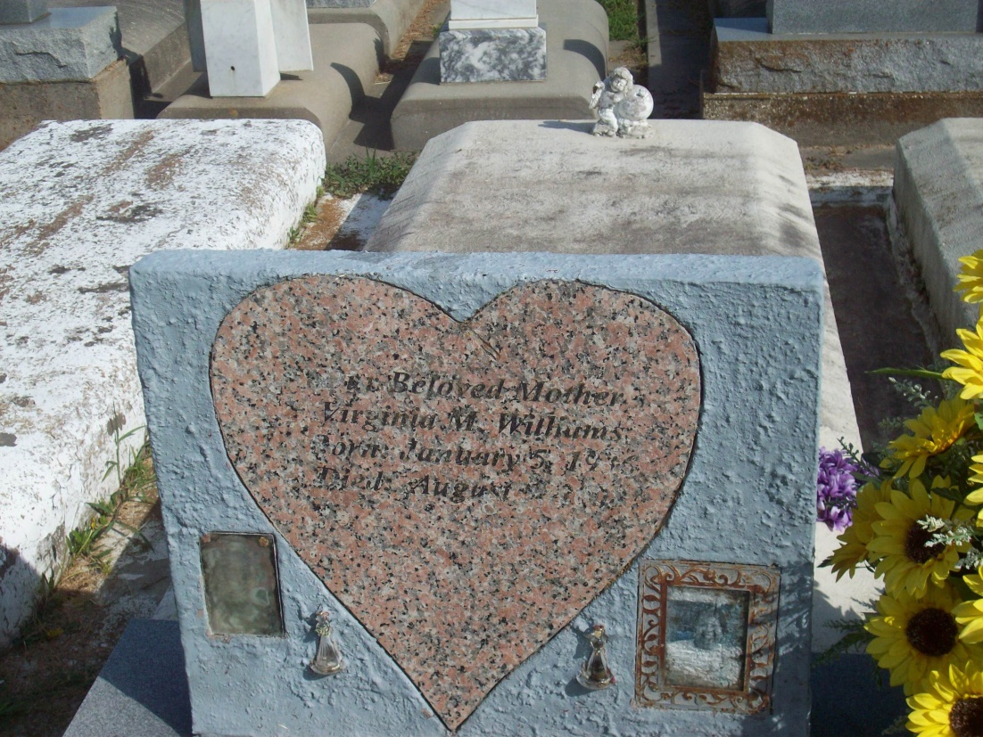

Photo by TMB

Virginia Melancon Williams at Thibodaux General Hospital in Thibodaux, LA, at 3:50 a.m., on Tuesday, August 5, 2008. Daughter of the late Alexander Melancon and Lorenza Steib Melancon. Wife of the late Albert Alvin Williams. Mother and mother-in-law of Iris and David Walker, Allen and Connie Williams, Cheryl Domino and fiance, Bobby, Melissa Williams and fiance, Phillip and Jenard Williams. Sister of Eva Mae (Lawrence) Hall, Henry Melancon, the late Emily Weatherspoon, Lorenza Favorite, Rita Carter, Ferdinand, Joseph and Alexander Melancon, Jr. Also survived by 11 grandchildren, 5 great-grandchildren, nieces, nephews, cousins, other relatives and friends including, Ellen Fletcher. Age 72.

Unknown source