Gloria Ianta Mae Simmons Fields
December 20, 1941 - July 4, 2025

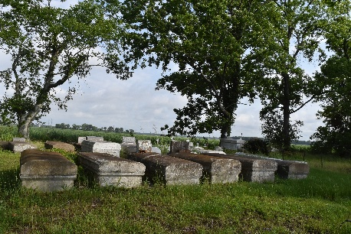
Gloria Ianta Mae Simmons Fields. known to everyone as "Mae" was born to the parentage of Louiza Young Simmons and Nathaniel Simmons on December 20, 1941, in Convent, Louisiana. On July 4, 2025, at 12:15pm, surrounded by her family, "Mae" peacefully entered into eternal rest.
A native of Convent and resident of Reserve, Gloria was baptized in the Mississippi River by the late Rev. Moses Russ. Gloria was educated in the St. James Parish School System. She graduated from Cypress Grove High School, then attended Southern University. Gloria was employed for 29 years as a secretary at Romeville Boys Division, which was later renamed Romeville Elementary School. She was a longtime member of Beech Grove Baptist Church, where she was a member of the deaconess board.
Gloria was a light, and she had a contagious smile. She loved her family and was very proud of their accomplishments. She loved serving God, writing encouraging letters and reading her Bible. She believed in keeping her family close. Her favorite things to do were eating at Golden Corral, watching her Golden State Warriors on television, and traveling to Texas to visit Monique.
Gloria leaves a lifetime of memories to be treasured by her daughters: Monique May(Harold) of Sour Lake, TX, Myrsa Simmons of LaPlace, LA and Jewel Simmons of Reserve, LA; her grandchildren: Damon Perrilloux II(D'iara), Aareon Johnson, Paris Simmons, London Simmons, and Kash Gray; 2 great-grandsons : JonTrayl and Ja'Man Williams; godchildren: Jeffrey Allen, Melissa Milton, and Leon Jones and a host of nieces, nephews, cousins, other relatives, friends and the Beech Grove Baptist Church Family.
Gloria was preceded in death by her parents: Nathaniel and Louiza Simmons, Siblings: Joseph, Mack, and Mose Simmons, Dolores Simmons, Frances Howard, Helen Simmons, Alma Hayes, and Preston Joseph; her nephews Marlon Simmons, Alston Robinson, Andre Simmons, Rev. Joe Howard; her great nephew Joshua Jones and a family friend Curtis Morrison.
Relatives and friends of the family, pastors, officers and members of Beech Grove Baptist Church, Pleasant Hill Baptist Church, Romeville, LA, St. James Parish School System and former employees of Romeville Elementary School and all neighboring Churches are invited to the Celebration of Life Services at 10:00am on Saturday, July 12, 2025, at Beech Grove Baptist Church, 117 Beech Grove Drive, Reserve, LA 70084. Pastor Corey Batiste, Officiating. Visitation at 7:00am until time of service at the above-named Church. Interment Pleasant Hill Baptist Church Cemetery, Pleasant Hill Street, Romeville, LA 70723.

Patrick H. Sanders Funeral Home, LaPlace, Louisiana
Jul. 8, 2025

