James Philip Ambrose

May 20, 1940 – November 11, 2019

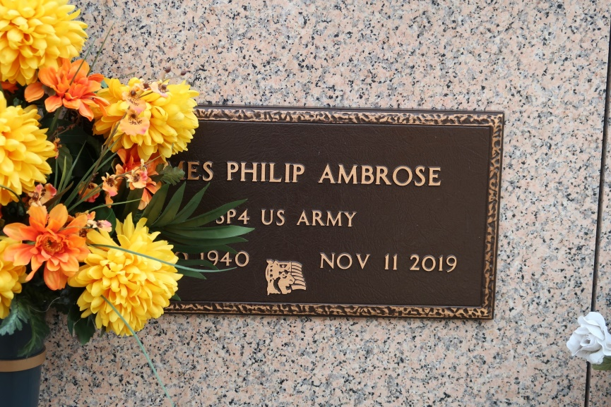

James Philip Ambrose was born on May 20, 1940 and transitioned on November 11, 2019.

He leaves to cherish his wonderful memories, his wife: Maxine Luke Ambrose, one daughter: Jaye Ambrose, two grandchildren: Jalynn Moll (LeKeem) and Jarvis Moll, Jr., two great-grandchildren Jaylee and Kelani, seven brothers: Jules, Jesse, Jeffery, Joshua, Jerome (Loletia) Ambrose, Jacob (Patrice) Ambrose, David (Lois) Mayho and three sisters: Jerralyn Ambrose-Bazile (Elvin), Joyce Ambrose, Janice Roussell (Dwight).

James is preceded in death by his parents, Joseph and Florestine Ambrose, Sr., two brothers: Joseph Jr., Louis John Ambrose Sr., and one sister Louise Ambrose.

Mass of Christian Burial will be held on Saturday, November 16, 2019 at St. James Catholic Church, 6613 LA-18, St. James, LA 70086. Visitation begins at 9:00 am followed by funeral service at 11:00 am. Entombment at St James Catholic Church Cemetery.   
 Final care has been entrusted to Treasures of Life Funeral Services, 315 E. Airline Hwy, Gramercy, LA 70052.

Treasure of Life Funeral Services, Gramercy, LA