Louis Joseph Andermann

November 5, 1930 – April 27, 2020

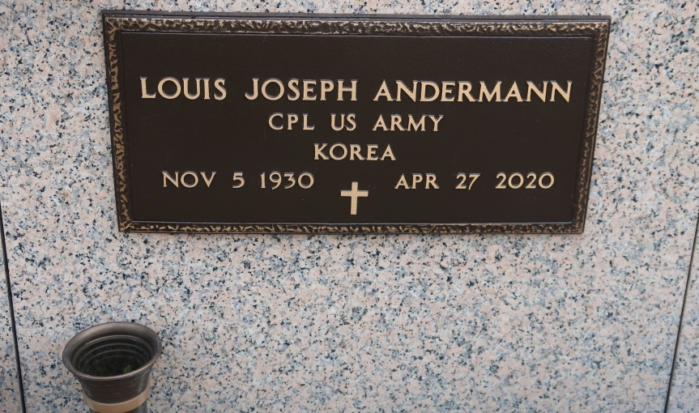

Louis Joseph Andermann, lifelong resident of St. James, passed away on Monday, April 27, 2020. He was 89 and a retired Post Master. Louis also served his country as a Medic in the U.S. Army on two tours during the Korean War. He was an avid fisherman, hunter, crawfisherman, gardener, beer drinker and card player. Louis was also a lifetime member of the St. James Hunting Club.

He is survived by his adoring wife of 65 years, Audrey Matherne Andermann; two daughters, Elizabeth Andermann Landry (Scott) and Susan Andermann Noto (Michael); son, Michael Andermann; 6 grandchildren, Nicole Fields (Jody), Lance Landry (Kayla), Ross Landry, Kandis Furrate, Layne Furrate, Abbey Andermann; and 3 great grandchildren, Zoe Fields, Lillian Landry, Layton Landry; Louis was preceded in death by his son, Anthony Andermann; parents, Antoine and Emma Hymel Andermann; and all his siblings.

A private service will be held. To offer your condolences to the family please visit, [www.oursoDonaldsonville.com](http://www.oursoDonaldsonville.com).

The Advocate, Baton Rouge, LA

Tuesday, April 28, 2020  
Contributed by Jane Edson