Douglas Keith Robert Arceneaux

October 3, 1957 – January 9, 2014

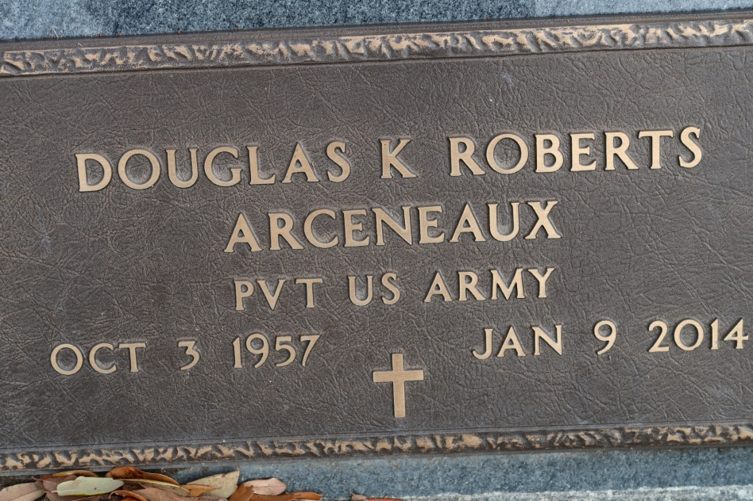

A Maritime Captain and Hazmat Instructor, he passed away Thursday, Jan. 9, 2014. He was 56, a native of Mobile, Ala., a resident of Ascension Parish, and a U.S. Army veteran.

Graveside services were held at St. James Catholic Church Cemetery on Monday, Jan. 13. He joined the U.S. Army in 1980. Went to work and had a career with Maritime International as a Captain. Moved to St. James, La. and later worked as a Chemical Hazmat Instructor and worked with the St. James Sheriff’s Dept.

Gonzales Weekly Citizen, Ascension Parish, LA

Thursday, January 23, 2014  
Contributed by Jane Edson