Marjorie (Walters) Arceneaux

August 7, 1936 – September 30, 2005

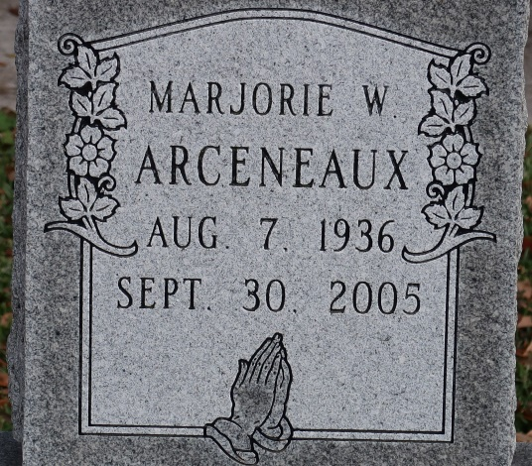

A resident of St. James and a native of Moselle, Miss., she passed away at her home in St. James at 5:20 a.m. on Friday, Sept. 30, 2005. She was 69 and a retired insurance agent for Insurance Unlimited.

Visitation at St. James Catholic Church, St. James, on Monday, Oct. 3, from 8 a.m. until recitation of the rosary at 9:30 a.m. Mass of Christian Burial at 10 a.m., celebrated by the Rev. Louis Oubre. Interment in the church cemetery.

She is survived by her husband, Robert Louis Arceneaux Sr., St. James; two daughters and a son-in-law, Carmen and Mike Ryland of St. James and Kim Buratt of Galvez; a son, Keith Arceneaux of St. James; an adopted grandson, Andre' "Jonathan" and wife Amber C. Arceneaux; two stepsons, Robert Louis Jr. and wife Annette G. Arceneaux and Aristile Daniel Arceneaux; stepdaughter, Melissa Ann and husband Anthony Johnson; three sisters and a brother-in-law, Marilyn I. Burns, Meriam L. and Glenn Brigman and Maris O. Roberds; two brothers and sisters-in-law, Virgil Michael and Melanie C. Walters and James Milo and Betty Walters; 11 grandchildren, Shea S. Wing, Johnny M. Noel III, Daniel P. Arceneaux, Bradley D. Wing, Kaleb M. Boudreaux, Jacquelyn M. Jones, Adrian L. Buratt, Vernon P. Ryland, Sarah M. Ryland, Penny Roberts and Brent Roberts; and a great-grandchild, Dominick Westley Arceneaux. She was preceded in death by her parents,   
Virgil J. and Luna M. Dykes Walters; a daughter, Leslie James Arceneaux; and a grandson, Ricci Scott Waites.

Arrangements by Ourso Funeral Home, Donaldsonville

The Advocate, Baton Rouge, LA

Sunday, October 2, 2005  
Contributed by Jane Edson