John Seraphim Armant

June 1803 – August 12, 1859

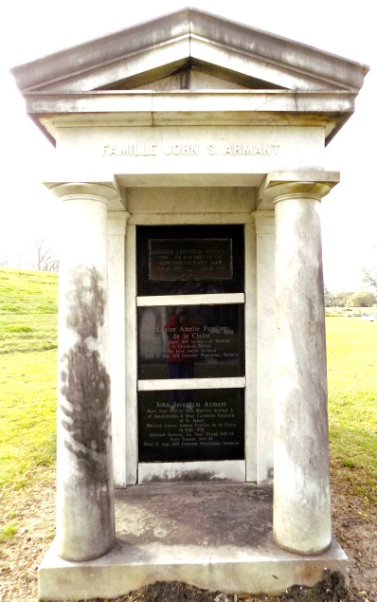 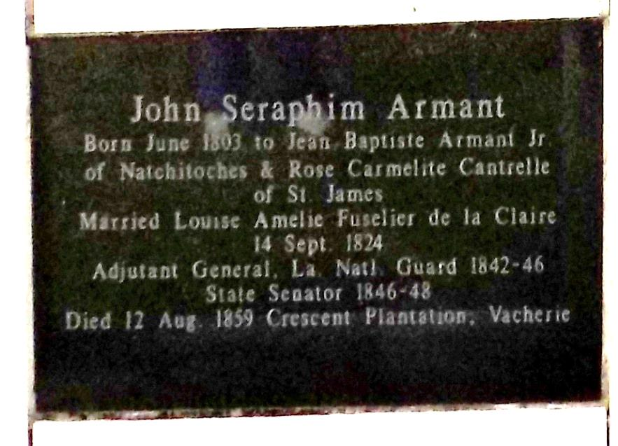

ARMANT, John S., planter, adjutant general. Born, September, 1801; son of Jean-Baptiste Armant and Rose Carme-lite Cantrelle. Married Louise Amélie Fuselier de la Claire in St. Martinville, September 14, 1824. Father of Col. Leopold Armant (q.v.) of the Eighteenth Louisiana Regiment who was killed at Mansfield, April 8, 1864. Named adjutant general by Gov. Alexandre Mouton (q.v.) and also served under Gov. Isaac Johnson (q.v.). Served as state senator. Died, August 12, 1859; interred St. James Catholic Cemetery, Convent, La. TAG, LA

Sources: Evans J. Casso, Louisiana Legacy: A History of the State National Guard (1976); biographical notes, Military Library, Jackson Barracks, New Orleans.  
\*\*\*\*\*

His name is Jean Seraphin D'Aspit ST. AMAND son of Jean Baptiste D'Aspit-St. Amand & Rose Carmelite Cantrelle.

ARMANT, Jean Seraphin (Jean Baptiste & Rose CANTRELLE) bt. 24 Nov 1803, bn. age 5 1/2 months old, spo. Jean Baptiste Cantrelle and Seraphine Andre (SJA-3, 270)

Diocese of Baton Rouge Catholic Church Records

Volume 2, pg 28

Contributed by Janet Bertram