Helen Jane (Mitchell) Aubert
September 26, 1944 - January 25, 2025

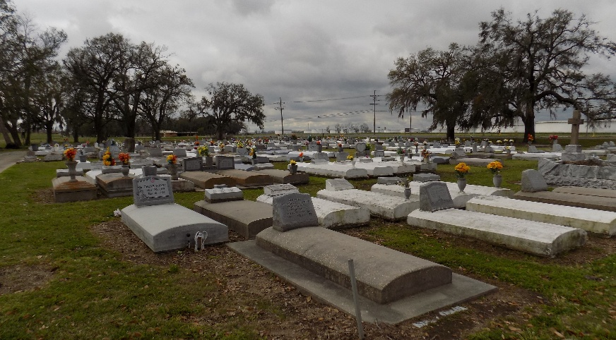

On Saturday, January 25 at 4:40 in the afternoon, the angel of the Lord escorted Helen Jane Mitchell Aubert to her heavenly home. Helen was born the second child of twelve on September 26, 1944 to the late Henry and Tampy Whittington Mitchell in Welcome, LA. Helen was baptized at the age of fourteen by the late Rev. Ernest Landry in the Mississippi River. She became a faithful member of Mt. Calvary Baptist Church and served as the President of the Missionary Board until her health failed. Helen was married to the late U.S. Naval Petty Officer First Class Roland Andrew Aubert and to this union Melissa Jane Aubert was born.
Helen graduated in 1963 from Magnolia High School. After graduating from high school, Helen worked at Touro Medical Center in New Orleans, LA as a surgical technician. After moving back to St. James, LA, she was employed by St. James Hospital as a surgical technician. The last 10 years of her career was completed at Lake Ascension Hospital in Gonzales, LA.
Helen was designated as the family’s historian. She was very crafty. Her hobbies included knitting and embroidery.
Helen leaves to cherish her memories her daughter, Melissa Jane Aubert; grandsons Chaz Nailor (Ja’Rae Lewis) and Chaney Nailor; great-granddaughter, Karlei (Snooch) Nailor; step-daughters, Madeline Gex, Gail Aubert Langston (Calvin) and Melinda Anderson; sisters, Mable (Leroy) Hill, Mary (Carl) Simmons, Kathleen Frazier and SueWon (Hilton) Narcisse; brother, Henry (Laura) Mitchell; brothers-in-law: Edward Scioneaux, Willie (Gwen) Honore’ and Herman (Florean) Aubert; sister-in-law, Ramona Mitchell; godchildren: Alfred Mitchell, Tonita Washington, SueWon Narcisse, Ryan Mitchell and Tondra White; devoted friends: Caldonia Ceasar, Marian Bailey, Ollie Dennis and Marguerite Taylor; and a host of aunts, uncles, nieces, nephews, relatives and friends.
She was preceded in death by her husband, Roland Andrew Aubert; parents: Henry Mitchell and Tampy Whittington Mitchell; sisters: Cheryl Honore’ and Lolita Scioneaux; brother: Karl Mitchell Sr.; father-in-law: Symphorien (Dago) Aubert; mother-in-law: Beula R. Aubert; brothers-in-law: Edgar (Celestine) Aubert Sr., Herbert (Leola) Aubert, Howard Aubert and Emile (Doris) Brown; and sister-in-law: Marie Aubert.
Helen's Homegoing Celebration will be held for 11am on Saturday, February 1, 2025 at Mount Calvary Baptist Church located at 8969 Highway 18 in St. James, LA. Viewing will be from 9am – 10:50am. Final viewing to start of service. Interment St. James Catholic Church Cemetery, 6613 Hwy 18, St. James, LA.

Treasures of Life Funeral Services, Gramercy, Louisiana
January 31, 2025

