Lorraine (Scineaux) Burke

February 23, 1940 – March 4, 2008

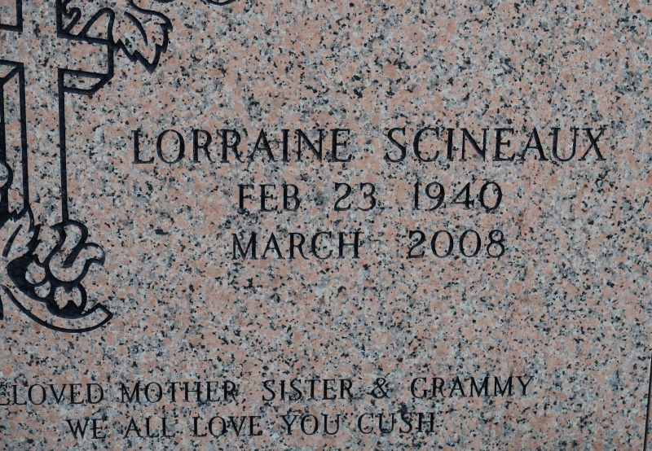

Lorraine Scineaux Burke at her residence in New Orleans, LA, at 12:20 p.m., Tuesday, March 4, 2008. Daughter of the late Paul Scineaux and Lillian Allen Scineaux. Wife of the late Daniel Burke, Sr. Mother of Lorraine Badr, Dwayne and Darryl Burke, Charles Scineaux and the late Daniel Burke, Jr. Sister of Betty Samuels, Martha Spencer, Shelia Morton, Linda Jones, Sylvester and Michael Williams. Mother-in-law of Lisa and Graziella Burke and Karen Scineaux. Sister-in-law of Freddie Morton, Nelson Jones and Jennifer Williams. Stepmother of Raphael, Gabriel, Stephon, Doris and Crystal Alfred and the late Michael Alfred. Also survived by 14 grandchildren, 3 great-grandchildren, nieces, nephews, cousins, other relatives and friends. Age 68.

Visiting on Monday, Mach 10, 2008 from 6:00 p.m. until 7:00 p.m. at the Funeral Home, Railroad Avenue, Donaldsonville, LA. Visiting on Tuesday, March 11, 2008 at St. James Catholic Church, St. James, LA from 9:30 a.m. until Mass of Christian Burial at 11:00 a.m. Conducted by the Rev. Louis Oubre. Entombment in Church Mausoleum. BRAZIER-WATSON FUNERAL HOME in charge of arrangements.

The Times-Picayune, New Orleans, Louisiana

Mar. 9, 2008