Maudrey Cantrelle

January 25, 1925 – November 17, 2016

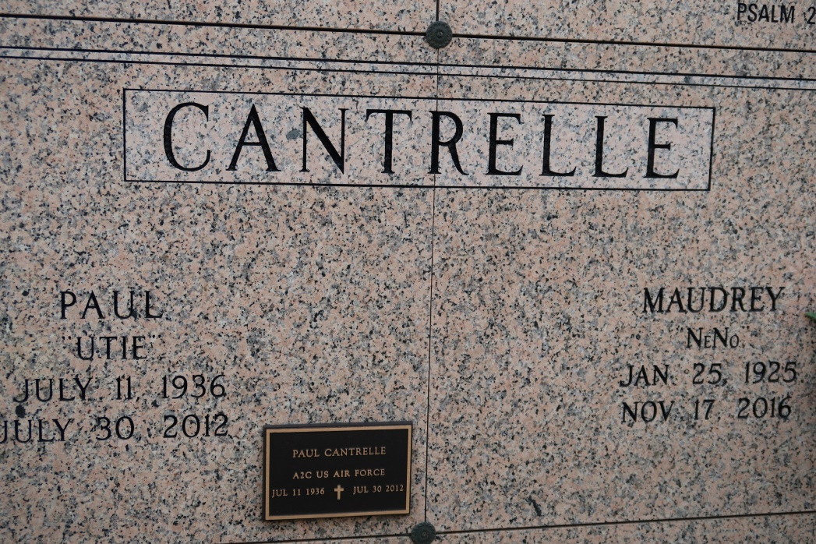

Maudrey Cantrelle, a native and resident of St. James. She passed away at 4:00 P.M., Thursday, November 17, 2016 at St. James Hospital in Lutcher. She was 91.

Visiting at St. James Catholic Church, St. James, Wednesday, November 23, 2016 from 9:30 A.M. until Mass of Christian Burial at 11:00 A.M., conducted by the Rev. Matthew McCaughey. Entombment in church mausoleum.

Survived by her nieces and nephews, Orrin, Antoine and Walter Cantrelle, II, Yvette Cantrelle Melancon, Rae'Shaun and Rydell Melancon, Jr., all of whom she reared. Godchildren, Devon Rome, Mary Ann Geason and Adriannne Ferchaud, cousins, other relatives and friends. Preceded in death by her parents, Paul Cantrelle, Sr., and Constance Ceasar Cantrelle. A sister, Mary Cantrelle and five brothers, David, Gerald, Henry, Walter, and Paul Cantrelle, Jr.   
 BRAZIER-WATSON FUNERAL HOME IN CHARGE OF ARRANGEMENTS. Visit us at www.brazierwatson.com to sign our guest book.

The Advocate, Baton Rouge, LA

Monday, November 21, 2016  
Contributed by Jane Edson