Paul Cantrelle

July 11, 1936 – July 30, 2012

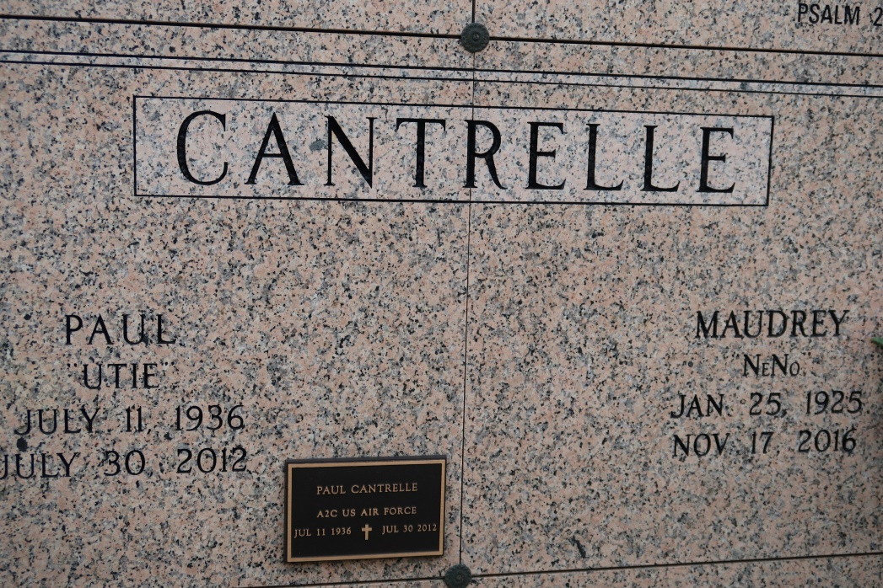

CANTRELLE - Paul "Chuck" "Utie" Cantrelle at his residence in St. James, LA, at 12:30 p.m., Monday, July 30, 2012. Son of the late Mary Cantrelle. Husband by first marriage to the late Stella Rodrigue Cantrelle and by second marriage to Mary Collins Cantrelle. Father and father-in-law of Yvette and Rydell Melancon, Sr., Orin and Michel Cantrelle, Karen and Lincoln Arceneaux and Wayman and Carol Arundel. Brother of Dorothy Mae Jones, and the late Annie Mae Geason. Also survived by 10 grandchildren, 7 great-grandchildren, nieces, nephews, a devoted aunt, Maudrey Cantrelle, cousins, including, Marilyn Cantrelle Jones, other relatives and friends, including Lynn Nicholas. Age 76.

Visiting at St. James Catholic Church, St. James, LA, Saturday, August 4, 2012 from 9:30 a.m. until Mass of Christian Burial at 11:00 a.m. Conducted by the Rev. Christopher Decker. Entombment in Church Mausoleum.

BRAZIER-WATSON FUNERAL HOME in charge of arrangements.

Times Picayune, New Orleans, LA

From July 31 to August 3, 2012