Eunice Carter
November 26, 1948 – November 16, 2025

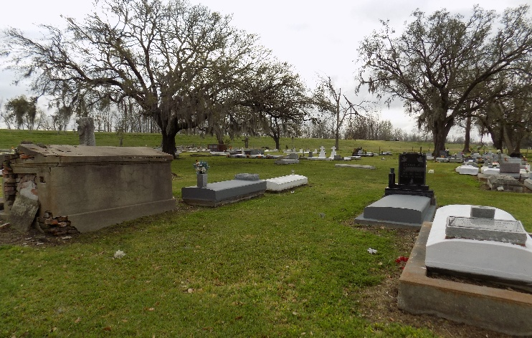

"The Lord is my Shepherd: I shall not want." Psalm 23:1

Eunice Carter affectionally know as Tutt, was born on November 26, 1948, to the late Mable Champagne Carter and Freddie Carter. On November 16, 2025, God dispatched his heavenly angels to escort him into the pearly gates of heaven.
Eunice had some schooling at Baytree School in Vacherie, LA. At an early age he had to leave school to help care for the family. He worked for Schexnayder Farms and Gragnuard Farms as a dedicated worker until he retired. He will be, remembered for his caring and supportive heart. Eunice was a faithful member of St. James Catholic Church. Spending time with family and friends was his greatest joy, especially being with his son Shonedall.
Eunice leaves to cherish his memory one son Shoendall Carter of New Orleans, LA, one daughter Tamahya Miller of Donaldsonville, LA. A devoted friend Beverly Alexander of St. James, LA, one step son, four step daughters, five grandchildren, Brelund Rounds, Shamar Harris, Demarcus Russell, Shamar Anderson and Amaya Russell, four great grandchildren Kaylise Rounds, Jayniya Sayor, Kcion Williams and Kenzly Anderson, two brothers Jessiner "Tom Cat" Smith and Larry Carter, eleven step grandchildren, one step great grandchild, two devoted cousins Mary Lee Nelson of Vacherie, LA and Raymond Champagne of Atlanta, GA, one godchild Joy Aubert and a host of nieces, nephews, cousins and friends.
Eunice was preceded in death by his parents Mable Champagne Carter and Freddie Carter, two brothers Freddie Carter Jr and Bill Champagne (Ethel Mae), aunts, uncles and cousins.
A Mass of Christian burial will be held on Saturday, November 29, 2025, at Saint James Catholic Church, 6613 LA-18, St James, La 70086 at 11:00am. Visitation will begin at 9:00am until service time. Interment at Saint James Catholic Church Cemetery.

Treasures of Life Funeral Services, Gramercy, Louisiana

