Harden J. Cayette

March 2, 1925 – August 23, 2010

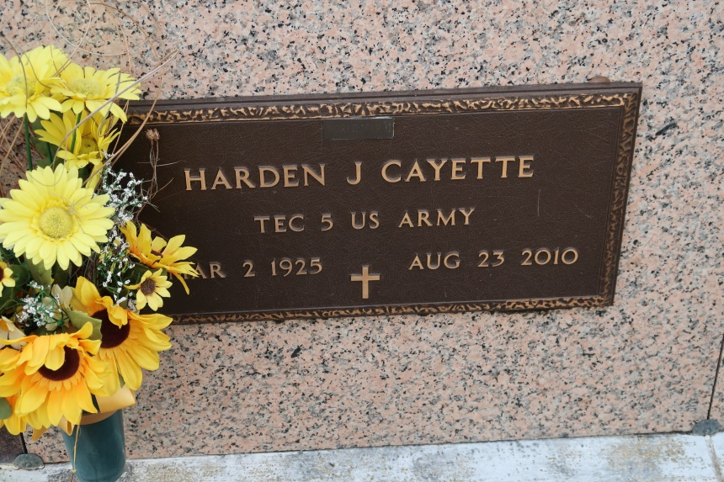

Harden Cayette, a native and resident of St. James, died at 10:27 a.m. Monday, Aug. 23, 2010, at home. He retired from the St. James Parish Sheriff's Office after 31 years. He was 85 and an Army veteran.

Visiting at St. James Catholic Church, St. James, the Rev. Chris Decker, pastor, Mass of Christian Burial, celebrated by the Rev. Louis Oubre. Entombment in the church mausoleum.

He is survived by four daughters, Cherlyn Cayette Barnes, Minister Gloria and husband Pastor David Griffin, Janet Brown and Janice Madison; two sons, Harden Joseph and Harding and wife Debbie Joseph; a sister, Ida Mae Schomberg; a brother, Carrol J. Sr. and wife Eloise Cayette; a devoted nephew and caregiver, Daniel Johnson; 15 grandchildren, 14 great-grandchildren, numerous nieces, nephews, cousins, other relatives and friends.

He was preceded in death by his parents, Ernest Cayette and Alphfosine Gainer Cayette; a daughter, Beverly Cayette; two sisters, Belle Gabriel and Beatrice Cayette Ester; and two brothers, Ernest Cayette and Arthur Johnson.   
 In lieu of flowers, donations to St. James Catholic Church are preferred. Arrangements by Brazier-Watson Funeral Home of Donaldsonville

The Advocate, Baton Rouge, LA

Friday, August 27, 2010  
Contributed by Jane Edson