Maude (Jackson) Cayette

September 10, 1953 – January 10, 2001

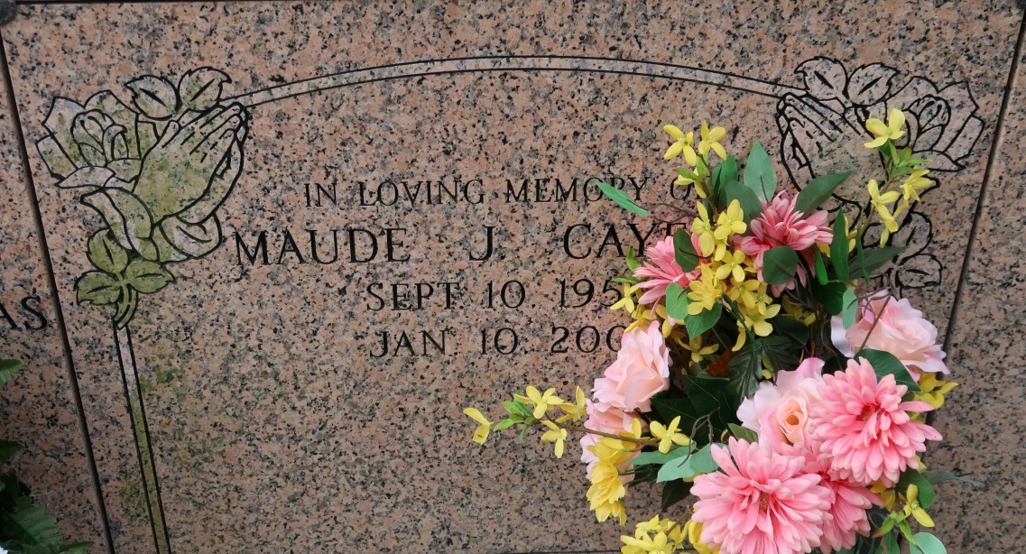

ST. JAMES - Maude Jackson Cayette, 48, a native and resident of St. James, died Jan. 10. She was the wife of Milton Cayette Jr. and mother of Roshanda and Milton Cayette III. She was also the daughter of the late Dolman Sr. and Maude Philip Jackson and sister of Shirley Ray, Rose Bottley, Elsie Jackson, Angela Cayette, Dolman Jackson Jr. and the late Virginia Steib. She was a retired plant operator at Motiva in Convent. Services are today at 11 a.m. at St. James Catholic Church, St. James, with interment at the church mausoleum. Visitation starts at 8 a.m.

L'Observateur, LaPlace, LA

January 13, 2001