Chad Everette Coleman

July 30, 1973 – March 14, 2015

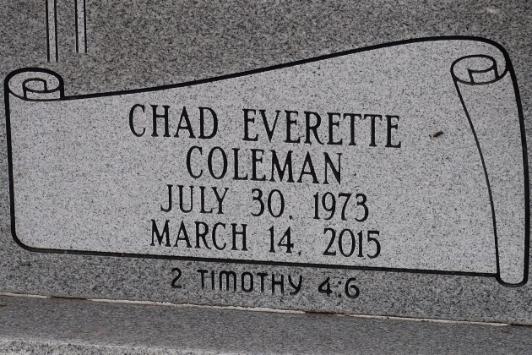

A native and resident of Gramercy. Chad passed away at Baton Rouge General Hospital- Bluebonnet, Baton Rouge at 3:10 P.M. on Saturday, March 14, 2015. He was 41.

Visiting at St. James Catholic Church, St. James, Saturday, March 21, 2015 from 9:00 A.M. until Mass of Christian burial at 10:00 A.M. conducted by the Rev. Christopher Decker. Interment in church cemetery.

Survived by his wife, Nadine Harris Coleman. His daughter, Cadence. His mother, Betty Cooper Coleman. His brother, Ronaldo Coleman and wife, Anastasia. Mother in law, MaeBelle Harris; two sisters in law: Wanda (Donald) Sanders and Evangeline (Rodney) August, and numerous aunts, uncles, 2 nieces, a nephew, cousins, other relatives and friends.

Preceded in death by his father, Willie Coleman. His sister, Terry Lynn Coleman. Maternal and Paternal grandparents and his father in law, Ernest Harris, Jr.

BRAZIER-WATSON FUNERAL HOME IN CHARGE OF ARRANGEMENTS.

The Advocate (Baton Rouge, LA) from Mar. 19 to Mar. 31, 2015.