Frank J. Dorsey Jr.
August 16, 1996 - April 28, 2025

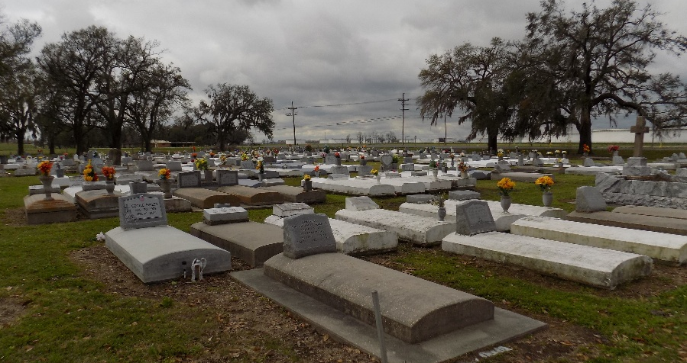

With a spirit full of laughter and an unwavering determination, Frank J. Dorsey Jr., affectionately called Rudy, truly embodied the essence of II Timothy 4:7-8, "I have fought the good fight, I have finished the race, I have kept the faith." Born on August 16, 1996, in Baton Rouge, LA, Frank was a beacon of strength and love to all who knew him. Despite leaving us on April 28, 2025, his memory, like the faith he held strong, remains everlasting.
Frank was a proud graduate of St. James High School, Class of 2016, and built a respected career as a scaffold builder in the construction industry, contributing to prominent projects with Turner, Brock, Apaches, and Mosaic. His hardworking nature was only rivaled by his love for life, particularly his passion for fishing, storytelling, and drawing. Each joke he told, every line he drew, echoed his vibrant spirit. This same spirit was reflected in his profound respect for his elders and his readiness to lend a hand to those in need. His favorite saying to his sister, Marvinlette Octave, "Our momma didn't raise us like that!" perfectly encapsulates the values instilled in him by his beloved mother, Gale Farnell.
Frank's journey was one of courage and faith. His decision to return to Jesus, a journey his loved ones celebrate proudly, is a testament to his strength. His legacy lives on through his mother Gale, his sister Marvinlette Octave and brother Marvin Mayho, his children Da’kai Wilson, Kaison Dorsey, and Zoe Francois, and his extended family.
He is preceded in death by his father, Frank Dorsey Sr., his stepfather Wayne Farnell, and other dear family members. His memory will forever be cherished by all who knew him, and he will never be forgotten.
The celebration of Frank's life will take place at St. James Catholic Church, 6613 La Highway 18, St. James, LA 70086, on Friday, May 9, 2025, at 11:00 am, with viewing from 9:00-11:00 am and Rosary at 9:30 am. Rev. Mike O’Rourke will be the celebrant, and a repast will follow at St. James Catholic Church Hall.

Treasures of Life Funeral Services, Gramercy, Louisiana
May 5, 2025

