Dennis Kirk Duronslet, Sr.
September 15, 1971 - February 1, 2025

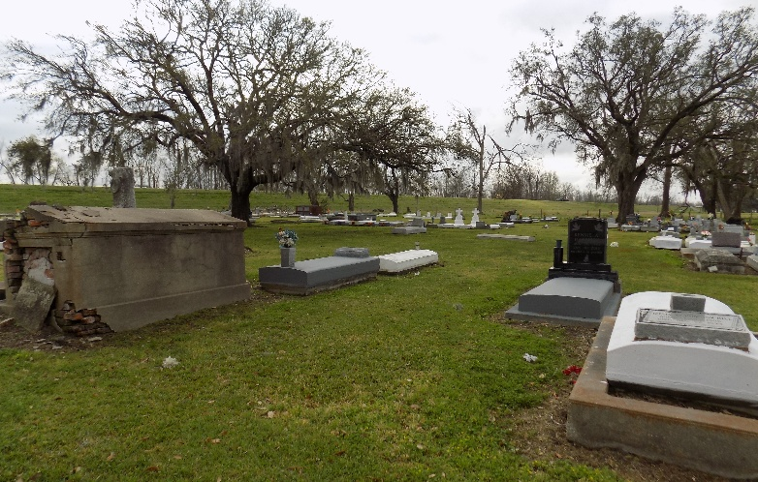

On Saturday, February 1, 2025, at 10:04 a.m., an angel of the Lord escorted Dennis Kirk Duronslet, Sr., known to many as “Doo Doo”, to his heavenly home. Dennis was born on September 15, 1971, to Joel Michael, Sr. & Roberta Gauthreaux Duronslet in St. Charles Parish. He was baptized at Holy Rosary Catholic Church in Hahnville, LA. In his early years, he attended Carver Elementary School in Hahnville, LA., from grades Kindergarten to Fifth. Later, Dennis & his family moved to St. James Parish; there he attended Fifth Ward Elementary School, graduating from St. James High School in 1990. He was an incredible athlete in football and track.
After completing high school, at the age of 18, he immediately began working at Agrico Chemical with his dad & brother. He was also employed with Boh Brothers Construction Company for five years. At the time of his passing, Dennis was employed with SKR Construction in Convent, LA., as a heavy equipment operator. He also assisted his wife with her photography business.
He was well known for his delicious cooking, especially his signature pastalaya. He would stand next to you and watch you eat, saying, “I know it’s good”. Dennis bled black & gold as he was a diehard fan of his high school St. James Wildcats & New Orleans Saints. He remained a faithful fan to the Saints, no matter how bad the season was. This led to many arguments with his brother, who is an avid Dallas Cowboy fan.
In 1993, he became the proud father of his son, Dennis Kirk Duronslet, Jr., also known by family and friends as “LD”, whom he brought up around football coaching little league team, the “Prairieville Broncos”. A new chapter began in February 2011, when he began dating Katicka. On September 21, 2013, they were joined in Holy Matrimony, creating a beautiful, blended family with her daughter, Airien & his son, LD. Dennis absolutely adored his two granddaughters, Maci & Aubri, who were the apples of his eyes.
Dennis leaves to cherish his memories, his loving & devoted wife, Katicka Cage Duronslet; son, Dennis Kirk Duronslet, Jr.; daughter, Airien Simoneaux; two granddaughters, Maci Duronslet & Aubri Semien; sister, Nicholle (Vincent) Bridgewater; brother, Joel Michael (Sharon) Duronslet, Jr.; two nieces, Ciera Gasery & Jireh Webster; two great nephews, Aschere & Dominic Gasery; mother-in-law Valerie (Quincy) Allen, Sr.; father-in-law, Ronald (Cheryl) Cage; two brothers-in-law, Quincy (J’Da) Allen, II & Clarence Cage; one sister-in-law, Ariel Allen; godparents: Oneal & Lee Oubre, three godchildren: Tayja Landry, Milan Williams & Shiren Gray; a host of aunts, uncles, cousins & friends.
He was preceded in death by his parents, Joel Sr. & Roberta Duronslet; grandparents, Ulysess Sr. & Florence Geason Gauthreaux & Dennis & Elmary Oubre Duronslet, and a host of aunts, uncles & cousins.

Demby & Son Funeral Home, Donaldsonville, Louisiana

