Stephen Roy Favorite
June 17, 1951 – April 2025

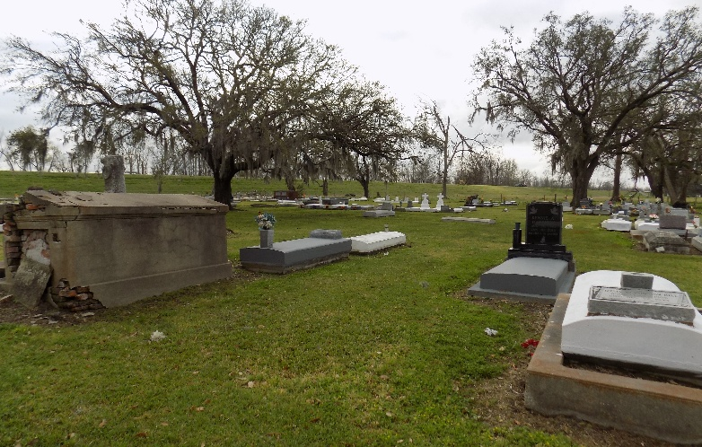

Stephen Roy Favorite, a devoted husband and father and longtime resident of New Orleans, LA unexpectedly departed this earthly life doing what he loved, creating something for others to enjoy.
A native of Vacherie, Louisiana, he's graduate of St. James High and Southern University before embarking on a career as a certified construction project manager and a licensed general contractor. He was founder and CEO of SRF Group Consulting, an architectural design and project management firm, and F3 Management, which developed multi-family housing communities in south Louisiana.
To cherish memories of moments together, Stephen leaves behind his wife and best friend of 32 years, Terese Bennett Favorite; sons, Aaron, Marcus, and Etienne; grandchildren, Layla, Ethan, Devereaux, Ziggy, and Edison Favorite; siblings, Wilson, Jr. (Elaine), James (Valerie), Anthony, Kathleen, and Juliette F. Richardson (Jerry); brothers-in-law, Angelois Washington, Sr., Timothy Bennett (Janice); sisters-in-law, Gabriella and Xochitl Bennett; and a host of other relatives and very close friends.
He was predeceased by his parents, Wilson, Sr. and Bertha Pierre Favorite; and his sister, Marie Roseanne F. Washington.
Funeral service and interment will be held at St. James Catholic Church and Cemetery, 6613 LA-18, St. James, LA on Friday, April 4, 2025 at 11:00 am. A Celebration of Life will be held at Xavier University of Louisiana's Administration Building Auditorium, 1 Drexel Drive, New Orleans, LA, on Saturday, April 5, at 3:00 pm. In lieu of flowers, the family requests donations be made to the Leukemia and Lymphoma Society in his memory.

Nola.com
April 4, 2025

