Mary Felisha Fefie
July 22, 1940 - July 7, 2025

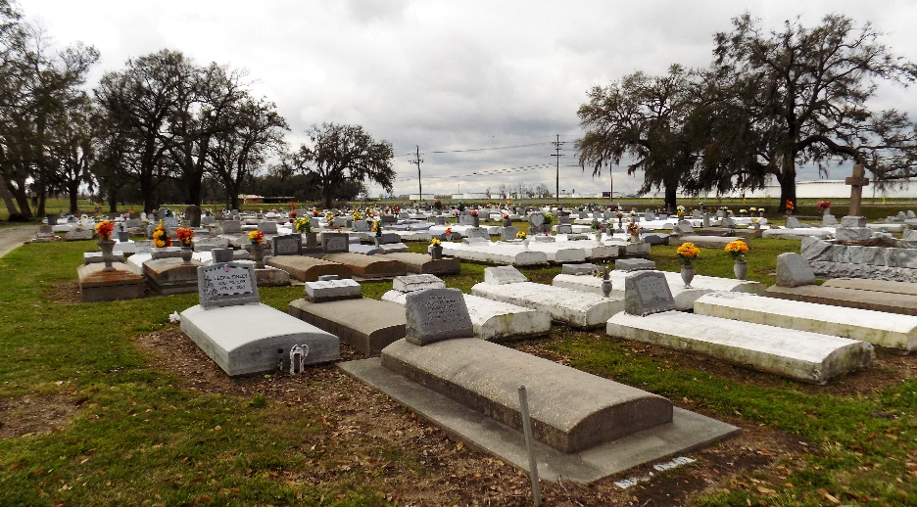

Mary Felisha Fefie departed this earthly life on July 7, 2025 at LCMC (formerly West Jefferson Hospital, Marrero LA) at the age of 84. She was educated at St. Louis School in Welcome, LA. After finishing high school she moved to New Orleans, LA and started working with the New Orleans School System for 55 years. After retiring she began doing private sitting and cooking for James K. Fieblem. Mary was also part of Ladies Auxiliary of New Orleans KPC 325.
Mary is survived by her two children: Norman A. Fefie of Houston, TX and Karen E. Fefie of New Orleans, LA; her siblings Joseph Fefie, Marie Odette Fefie, Marilyn Sutherland, and Antionette Fefie of St. James, LA, Betty Ann Jones of Darrow LA., Doris Truehill of Thibodaux, LA, Cleveland Fefie of Donaldsonville, LA and Theresa C Fefie of Los Angeles,CA.
Mass of Christian Burial will be held on Friday, July 18, 2025 at St. James Catholic Church, 6613 LA- 18, St James, LA 70086. Visitation from 8:30am-10:30am. Followed by Mass for 11am. Interment St. James Catholic Church Cemetery.

Treasures of Life Funeral Services, Gramercy, Louisiana
July 17, 2025

