Rita Helen Fefie

September 29, 1942 – October 14, 2004

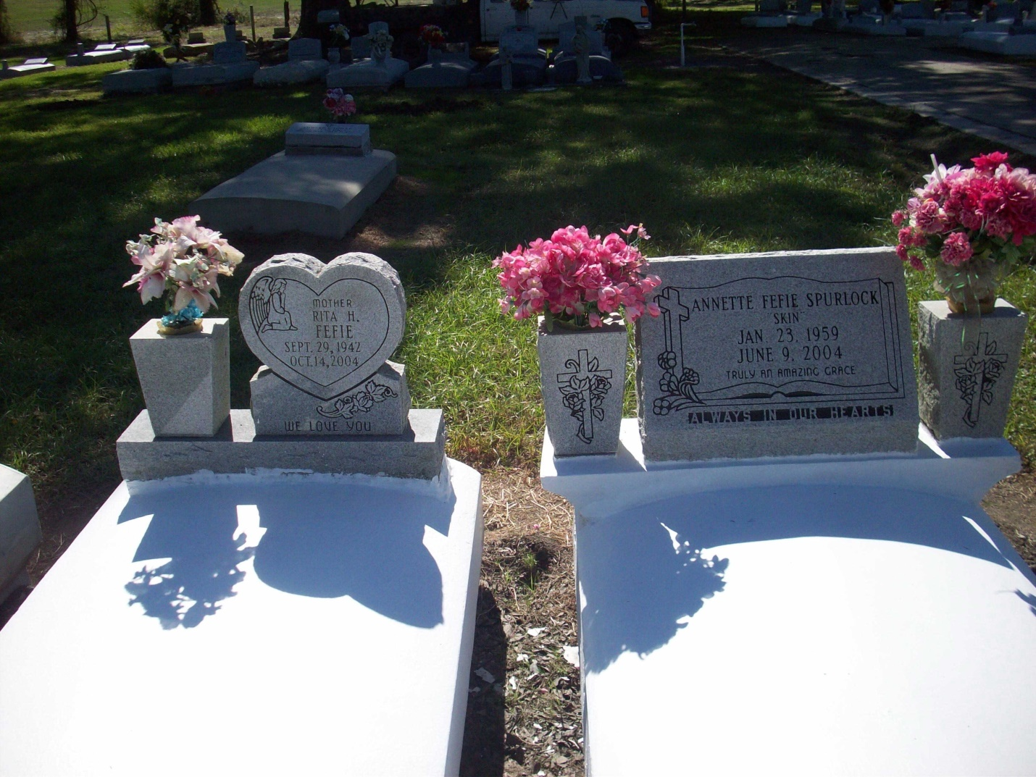

Photo by TMB

Rita Helen "Tot" Fefie, 62, a native of Welcome and resident of St. James, died Oct. 14, 2004. She was the mother of Bridget Silby, Cynthia, Anthony and Michael Fefie, and the late Wayne Fefie.  
 She was also the daughter of the late Alonzo and Beatrice Fefie, and sister of Doris Truehill, Theresa Zenon, Marilyn Sutherland, Betty Jones, Antoinette Skmmons, Mary, Odette, Clevenad and Joseph Fefie, and the late Annette "Skin" Spurlock.  
 She is also survived by 10 grandchildren and three great-grandchildren.  
She attended Magnolia High School and later earned her GED. She was a certified nursing assistant.

Unknown source