Margie (Monconduit) Ferchaud

July 9, 1918 - July 28, 2008

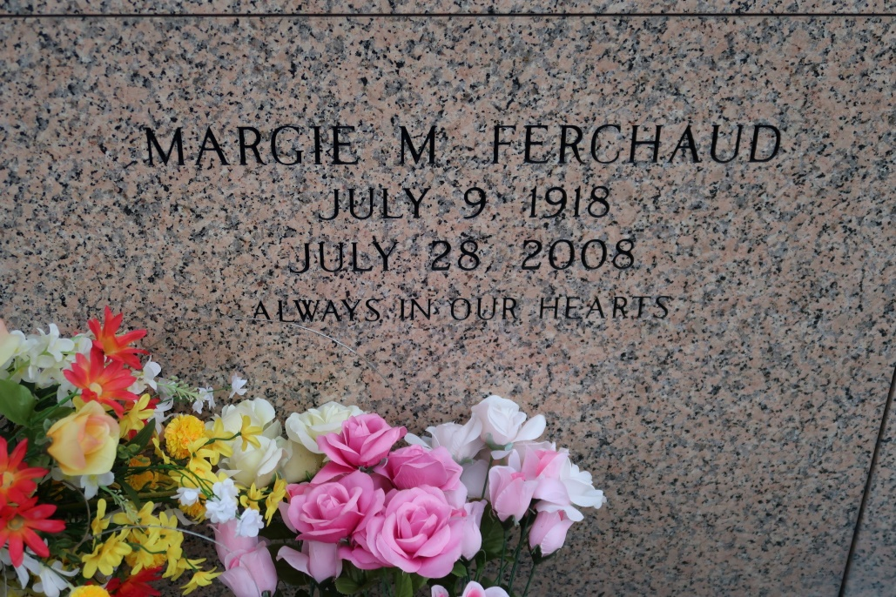

Margie Monconduit Ferchaud, 90

A homemaker and a resident of St. James, she died at 2:30 a.m. Monday, July 28, 2008, at St. Elizabeth Hospital, Gonzales. She was 90 and a native of Welcome.

Visiting at St. James Catholic Church, St. James, on Friday, Aug. 1, from 9 a.m. to 10:50 a.m. Religious service at the church at 11 a.m. Friday, conducted by the Rev. Louis Oubre. Entombment in the church mausoleum.

She is survived by a daughter, Anastasia Ferchaud; three sons and daughters-in-law, Kern and Janice, Anthony and Antoinette, and Raymond and Velma Ferchaud; sisters-in-law, Mildred Monconduit, Ora Lee Ferchaud and Marline Sutherland; 11 grandchildren and 12 great-grandchildren.

Preceded in death by her husband, Kern; son, Dolan Calvey; and siblings, Margaret, Lawrence, Albert, Melvin and Mark. She was a member of the Rising Sun Society. Arrangements by Baloney Funeral Home LLC, Garyville.

Advocate, The (Baton Rouge, LA)

Thursday, July 31, 2008