Vivian (Hughes) Folse

August 5, 1920 – February 28, 2019

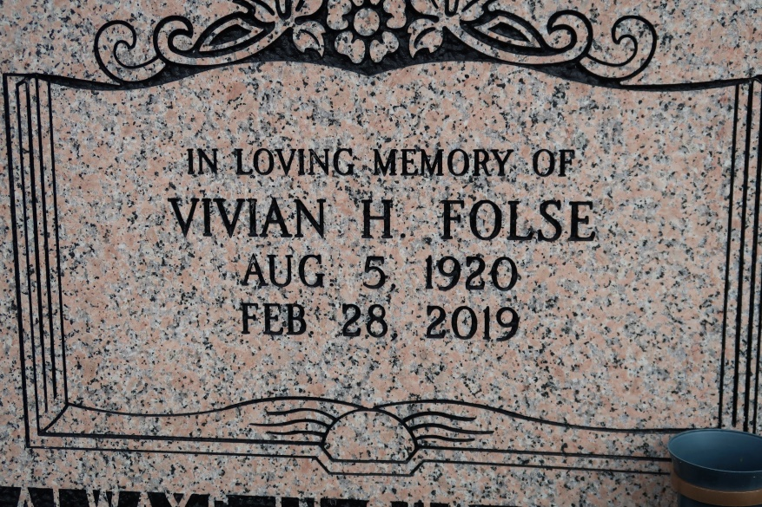

A native of Belle Alliance and a resident of St. James. She passed away at 12:40 a.m., Thursday, February 28, 2019 at The Crossing Rehabilitation Center in Baton Rouge. She was 98.

Visiting at St. James Catholic Church, 6613 Highway 18, St. James., Saturday, March 9, 2019 from 10;00 a.m. until Mass of Christian Burial at 12:00 Noon. Entombment in Church mausoleum.

Survived by her son, Robert Bowman and wife Suelyn. Her daughter-in-law, Joni Folse. Four grandchildren, nine great-grandchildren, numerous nieces, nephews, cousins, other relatives and friends.

Preceded in death by her parents, Alexander Hughes and Florestine James Hughes. Her husband, Nathan Folse, Sr. Her son, Nathan Folse, Jr. Her sisters: Francis Samuels, Millie Davis and Ruth Crumes. Her brothers: Clarence, Isaac, Marion and Alexander Hughes, Jr.   
 BRAZIER-WATSON FUNERAL HOME IN CHARGE OF ARRANGEMENTS. Visit us at www.brazierwatson.com to sign our guest book.

Advocate, The (Baton Rouge, LA)

Mar. 7 to Mar. 9, 2019