LaTasha Tennille (Sutherland) Geason
August 23, 1976 - October 2, 2025

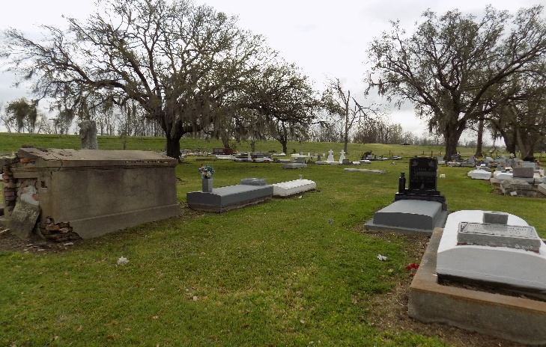

Friday, October 10, 2025 | 10:30 AM Saint James Catholic Church 6613 LA Hwy 18, St. James, LA 70086 Psalm 23: “The Lord is my shepherd; I shall not want. He maketh me lie down in green pastures: he leadeth me beside the still waters. He restoreth my soul; he leadeth me in the paths of righteous-ness for his name’s sake.” With our deepest love and most cherished memories. We announce the passing of LaTasha Tennille Sutherland-Geason, who departed her worldly life and transitioned to her heavenly home on Thursday, October 2, 2025.
Tasha, a native of Vacherie, Louisiana and resident of Addis, Louisiana, was born August 23, 1976, to the late Clinton Sutherland, Jr., and Elaine Jones-Sutherland. She was united in holy matrimony to the absolute love of her life, Terrence Geason. Young love beginning in 1992 grew into a union of one in 2005. From this union, 3 beautiful, amazing and wonderful children were born: Ellayna I. Sutherland, Terren A. Geason and Tren A. Geason. Tasha attended St. James High School.
She dedicated herself to several fulfilling careers. She worked as a product handler/ operator, with multiple companies, later finding her calling as a Logistics Dispatcher with LoadStar (Baton Rouge, LA). Her life was a beautiful blend of entrepreneurship, strength, passion, stamina, love, photography, creativity, and adventure. She embraced TikTok, delighted in new foods, planting, shopping, and traveling near and far. Yet, her greatest joy came from her devotion to family, friends, and the precious moments she shared with her grandchildren, she affectionately called her, “Saving Grace.”
LaTasha’s life was like a beautiful song, filled with lullabies of a true WARRIOR, a phenomenal woman, breast cancer survivor/advocate and beloved soul. Diagnosed with Stage 1 Breast Cancer in 2015; she faced a battle with unwavering strength. Fierce determination, the heart of a fighter. She was creative, a proud grandparent and was not afraid to try new things. Tasha was definitely a renaissance woman. She met every challenge with grace and courage, never allowing her illness to define her spirit. A survivor in every sense, she beat every fight and inspired everyone around her to adopt her resiliency. LaTasha’s legacy of strength, love, and perseverance will live on, in the hearts of all who knew her.
LaTasha is survived by her loving and devoted husband, Terrence Geason and their children: Ellayna I. Sutherland, Terren A. Geason and Tren A. Geason. Grandchildren: Kacey Spriggs, Kaztyn Spriggs, Emerie Coleman, Kross Spriggs. Furbaby: Nala “Pearl” Geason. Siblings: Clinton “Nuchey” Sutherland III, Ryan Sutherland, and Nicolette Sutherland. Mother-in-love, Judith Geason, Sister-in-love, Kim G. Jackson, Aunts, Mathilda S. Barnes, Cynthia, Andrea “Andy,” and Wendy Jones and Clarissa Oubre. One great aunt, Ora Lee Ferchaud. Uncles; Gerry, Herman (Charlene) & Thaddeus (Laura) Sutherland Sr. And Brice (Melissa) Jones. God-Father:Florian “Bugga” Oubre, Jr., God-Daughter: Maliah L. Bailey and a host of nieces, nephews, other family and friends.
She is preceded in death by her parents, Clinton Sutherland, Jr., and Elaine Jones-Sutherland. Maternal grandparents: Rita Keller-Jones and Alfred Jones, Sr., Paternal grandparents: Marlene Ferchaud-Sutherland and Clinton Sutherland, Sr. Uncles: Allen, Tyrone, Sr. and Eugene Sutherland, Sr., Alfred, Cornel, and Kenneth Jones and Meldon Borne Sr. Aunts: Joyce Sutherland-Geason, Zedel Sutherland-Oubre (God-Mother), Carla, Connie and Carol Jones, Stephanie Frye, Pamela Brown, and Cindy Sutherland. Father-in-love, Robert “Bobby” Geason III, Grand-in-laws, Thelma & Robert Geason Sr. and Edna-Mae & James Williams Sr.
A Mass of Christian Burial will be held on Friday, October 10, 2025 at St. James Catholic Church, 6613 LA-18, St. James, La 70086. Visitation begins for 8:30 followed by Mass for 10:30am. Father Mike O’Rourke officiant. Interment St. James Catholic Church Cemetery.
The Sutherland-Geason family extends our deepest gratitude to all who traveled near and far to join us in celebrating the life of LaTasha Tennille Sutherland-Geason. We are truly thankful for every call, prayer, flowers, cards and kind gestures that has comforted us during this time of bereavement. We especially want to thank our family, Judith Geason, Laura-Ann Sutherland, Mathilda Barnes and friend Nadia Williams. The compassionate staff of Baton Rouge General Hospital: Nurses and Respiratory Therapist: Jessica Herman, Corlis Bowie, Monique Cole, Valerie Garrett, Laura Guy, Takeisha Russel-Walker, Mr. & Mrs. Doyle and Chanreyelle Jones.

Treasures of Life Funeral Services, Gramercy, Louisiana
October 14, 2025

