Jacquelyn (Clouatre) Granier
November 15, 1949 – March 11, 2018

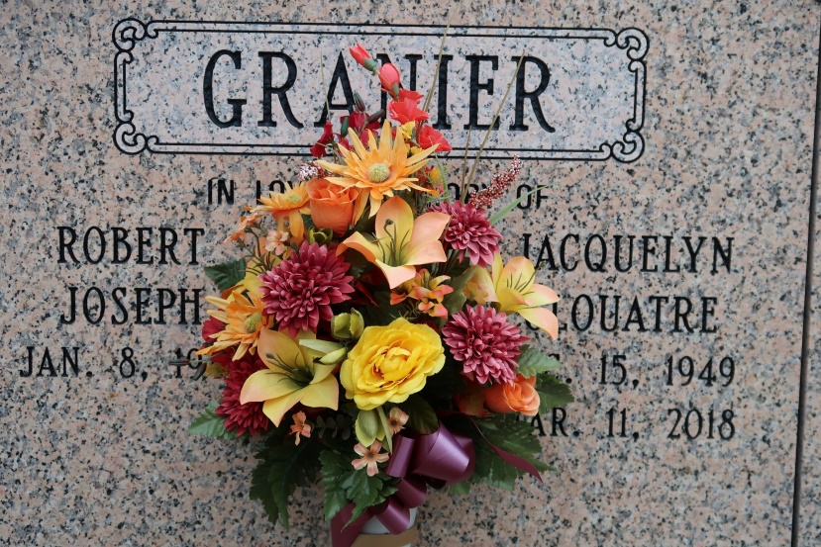

Jacquelyn Clouatre Granier, 68, a native of Baton Rouge and resident of St. James passed away on Sunday, March 11, 2018.
Jackie was a devoted Catholic and cherished her faith. Jackie enjoyed music, singing, baking and spending time with her family especially her grandchildren.
She is survived by her husband, Robert Granier; three children, Terry King (Toni), Troy King (Christy) and Chad King (Keren); two step-children, Leslie Granier (Kristi) and Lana Rousseau (Kevin); twenty-eight grandchildren; six great grandchildren; four sisters, Carolyn Delouise, Margie Wilson, Celeste Myers and Debra Blanchard and two brothers, LJ Clouatre and Gene Clouatre.
She is preceded in death by her two grandchildren, Dominic Andrew King and Leo Xavier King; parents, Livingston and Josie Clouatre; one sister, Patricia Brown and three brothers, Tracy, Gary and John Michael Clouatre.
The family requests that visitation be observed on Monday, March 19, 2018 from 8:30am until Mass of Christian Burial at 10:30am at St James Catholic Church. Interment to follow in church mausoleum.

The Advocate, Baton Rouge, Louisiana
March 16 - 19, 2018

