Kennie Anthony Harrison

August 26, 1983 – January 30, 2012

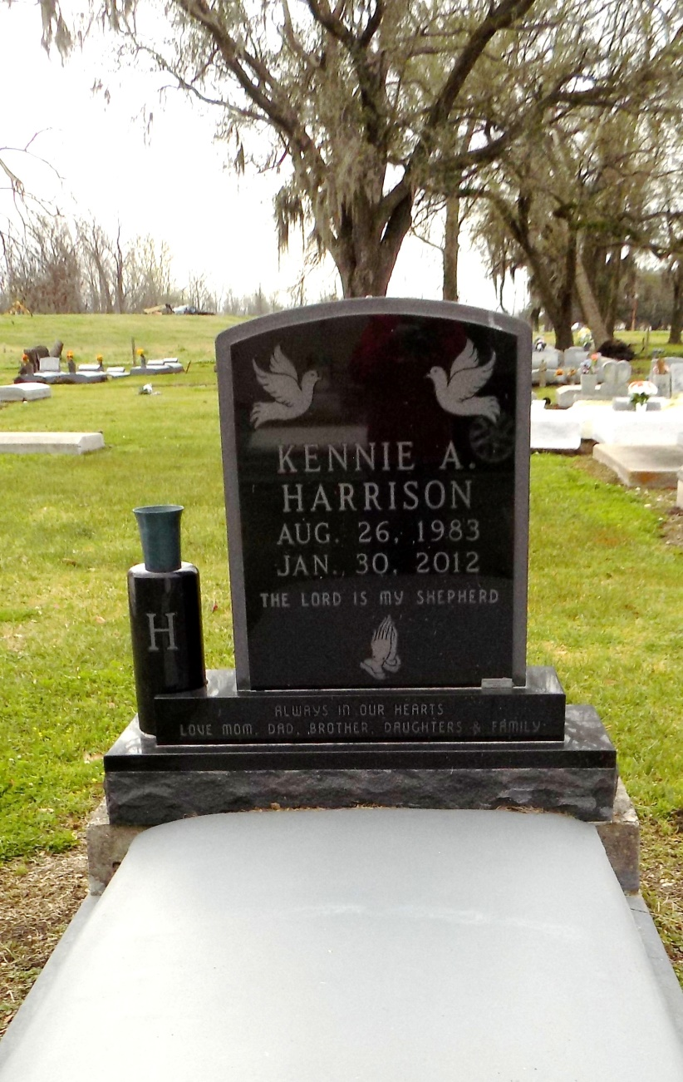

Kennie (PrimeTime) Anthony Harrison, departed this life on Monday, January 30, 2012 at the age of 28 years old.

Son of Melette Trepaigner and Craig Harrison. Stepson of Dolores Harrison. Father of Ke'lia and Lyric Harrison. Grandson of the late Aline and Dennis Trepaigner, Sr. and Audrey Harrison and the late Lawrence Harrison, Sr. Brother of Keaton Harrison, Tierney Harrison, Danielle (Darrell) McGlothen, and Shantell Louis. He is also survived by a host of nieces, aunts, uncles, and cousins.

Relatives and friends of the family, also priest and parishioners of St. Phillip Church, St. James Catholic Church, Assembly of God, and all neighboring churches. St. James Class of 2001, employees of Ormett Aluminum and Motiva are invited to attend a Mass of Christian Burial on Friday, February 3, 2012 at 11:00 a.m. at St. James Catholic Church, 6613 Hwy. 18, St. James, Louisiana. Father Chris Decker officiating. Visitation will be from 8:30 a.m. until time of service. Interment will be at the Church Cemetery. Funeral services entrusted to The Baloney Funeral Home, LLC 399 Earl Baloney Street, Garyville, Louisiana.

The Times-Picayune, New Orleans, Louisiana

February 1 - 2, 2012