Eazley (Scionneaux) Henderson

August 31, 1908 – October 4, 2001

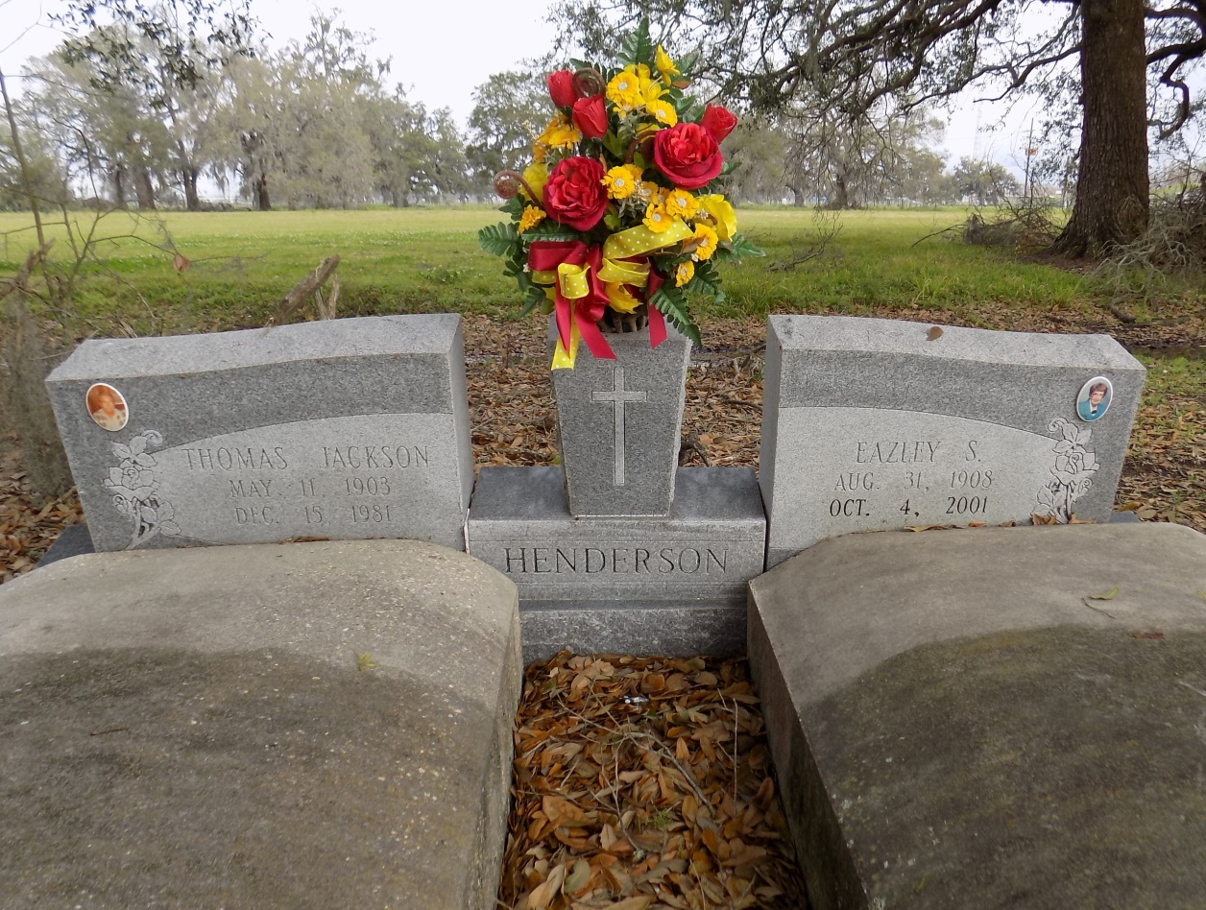

A Mass of Christian burial will be celebrated at 11 a.m. Saturday at St. James Catholic Church in St. James for Eazley Scionneaux Henderson, 93, a native of St. James Parish and resident of Thibodaux who died at 9 a.m. Oct. 4, 2001.

Visitation will be from 9 a.m. until funeral time at the church. Burial will be at the church cemetery.

She was the godmother of Connie S. Becnel; aunt of Thelma F. Smith, who is married to John Smith; Fernand "Bub" Falgoust, who is married to Jane Falgoust; and special neighbor of Hazel and Ronald Scionneaux. She is also survived by a host of other nieces and nephews.

She was preceded in death by her husband, Thomas "Jack" Henderson; parents, Wilson P. and Cecile Laiche Scionneaux; brothers, Schley and Harton Scionneaux; sisters, Nelva S. Falgoust and Adless S. Benson.

Thibodaux Funeral Home of Thibodaux is in charge of the arrangements.

Thibodeaux Daily Comet Lafourche Parish, Louisiana

October 5, 2001

Submitted by Don Johnson

Courtesy of usgwarchives.net