Cheryl (Mitchell) Honore

February 24, 1953 – December 31, 2009

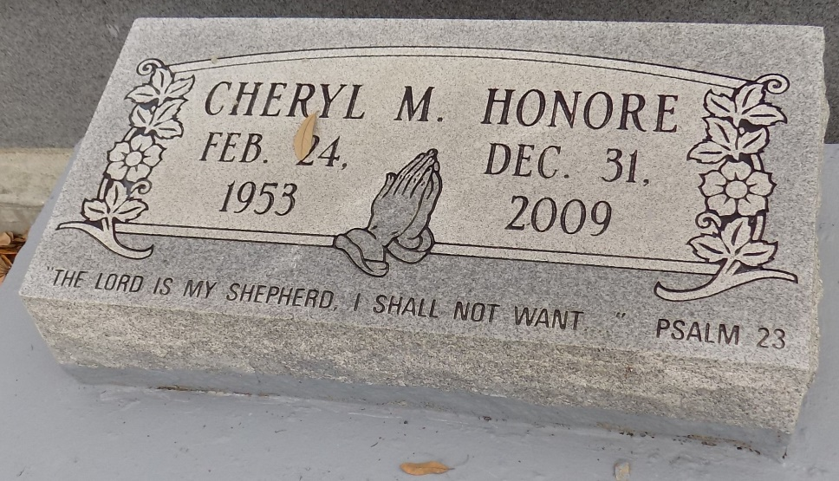

"The Lord is my Shepherd, I shall not want … " Psalm 23. This loving wife, mother and grandmother departed from this Earth shortly after 1 p.m. Thursday, Dec. 31, 2009, surrounded by family and loved ones at Our Lady of the Lake Regional Medical Center.

She was born to the union of Henry Mitchell Sr. and Tampy W. Mitchell in St. James on Feb. 24, 1953. She was baptized at St. James Catholic Church, where she practiced her faith until she married. She continued her faith at St. Anthony Catholic Church, Baton Rouge. She was the loving wife of Willie B. Honore, and to this union four children were born. She graduated from Magnolia High School in 1971 and Southern University in computer science in 1975. She was employed with the state of Louisiana for more than 30 years. She was preceded in death by her parents.

Cheryl leaves to cherish her memory her husband, Willie B. Honore; four children, Elliot and spouse Lakisha Honore, Dorothy and spouse LaRon White, Travis J. Honore, and Jessica Honore; two grandchildren; eight siblings, Lolita and spouse Edward Scioneaux, Helen Aubert, Mable and spouse Leroy Hill, Henry and spouse Laura Mitchell Jr., Karl and spouse Ramona Mitchell, Mary and spouse Carl Simmons, Kathleen Frazier, and SueWon and spouse Hilton Narcisse; sister-in-law, Gail and spouse Leroy Conish; brother-in-law, Cornel and spouse Hattie Honore; 13 aunts and uncles; and a host of nieces, nephews, godchildren and friends.

Visitation at St. James Catholic Church, St. James, on Thursday, Jan. 7, from 9 a.m. until Mass of Christian Burial at 11 a.m., with the Rev. Louis Oubre, celebrant. Interment in church cemetery. Arrangements by The Baloney Funeral Home.

The Advocate, Baton Rouge, Louisiana

January 6, 2010