Marie Ann (Waguespack) Hymel

October 13, 1924 – November 23, 2009

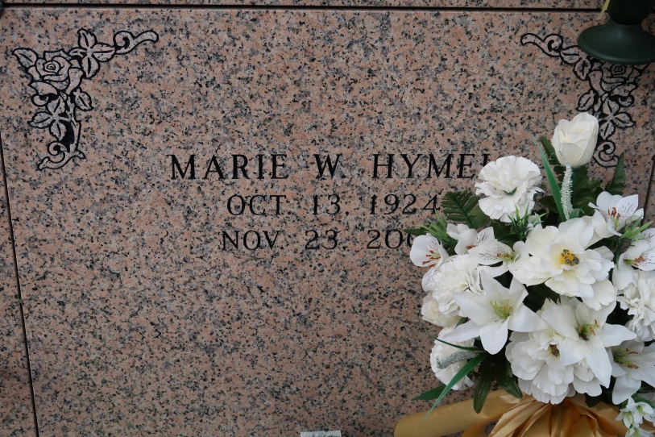

Marie Ann Waguespack Hymel, 85, passed away Tuesday, Nov. 23, 2009, at 4:54 p.m. at Thibodaux Regional Medical Center.

Marie had a special love of family and gardening. She is survived by three daughters, Joy Goss and husband Daniel, Marie Baughman and husband Christopher, and Yvonne Stein and husband Anthony; seven sons, Nelson Hymel Jr., Lee Hymel, Adrain Hymel, Alfred Hymel and wife Kristi, Danny Hymel and wife Melissa, Gerald Hymel, and Antoine Hymel and wife Tessa; sister, Alice Tabor and husband Philip; brother, Cyrille Waguespack; 12 grandchildren, Brandon Goss, George Hymel, Allison, Elizabeth and Nicholas Baughman, Linli and Logan Hymel, Melanie and Amanda Hymel, Samantha and Tyler Stein, and Jade Hymel; great-grandchild, Deven Hymel; and numerous nieces and nephews.

She was preceded in death by her husband, Nelson Pierre Hymel Sr.; parents, Marie Alice Zeringue and Joseph Lovincy Waguespack; three sisters, Marie Edvidge Troxclair, Elsie and Agnes Waguespack; and three brothers, her twin, Marian, Sylvester, and Antoine Waguespack.

Visitation will be at St. James Catholic Church, St. James, Wednesday, Nov. 25, from 8 a.m. to 10:45 a.m. Mass of Christian burial at 11 a.m. Entombment in St. James Catholic Church Mausoleum.

The Advocate, Baton Rouge, LA

Wednesday, November 25, 2009  
Contributed by Jane Edson