Stella (Nicholas) Johnson
February 14, 1931 — December 11, 2025

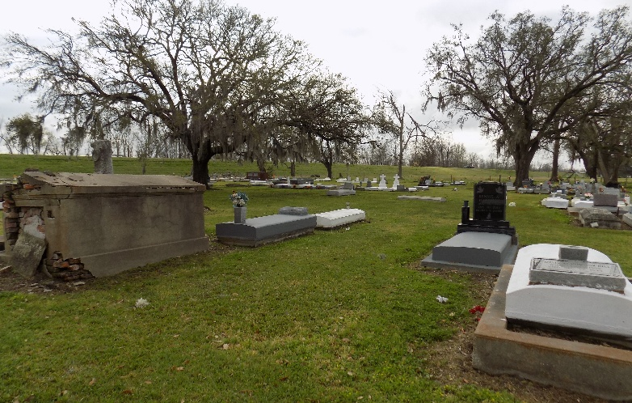

Stella Nicholas Johnson transitioned peacefully at her residence on Thursday, December 11, 2025, at the age of 94. She was a native of St. James, LA and a resident of Harvey, LA. Stella was a graduate of Southern University Baton Rouge, where she obtained a bachelors degree in Elementary Education. She was a retired educator with the California State School System. Stella was a faithful parishioner of St. Joseph The Worker Catholic Church and a member of the Good Shepherd Ministry, Hospitality Ministry, and Bulletin Brigade.
Loving wife of the late Marcellus Johnson. Beloved daughter of the late Clifford Nicholas, Sr. and Gustavia Bazile Nicholas. Devoted sister of the late Eddie, Clifford, Jr., Lawrence and Eddis Nicholas. Also cherishing her memories are a host of nieces, nephews, great nieces, great nephews, cousins, other relatives and friends.
Relatives and friends of the family, also priest and parishioners of St. Joseph the Worker Catholic Church and all neighboring churches are invited to attend a Mass of Christian Burial at St. Joseph the Worker Catholic Church, 455 Ames Blvd. Marrero, LA on Monday, December 22, 2025, at 10:00a.m. Father Sidney Speaks, celebrant. Visitation will begin at 9:00a.m.; Recitation of Rosary 9:15a.m.; Tribute to follow. Interment: St. James Catholic Church Cemetery-St. James, LA.

Davis Mortuary Service, Gretna, Louisiana

