Joann (Albert) Joshua
January 18, 1943 – March 18, 2022

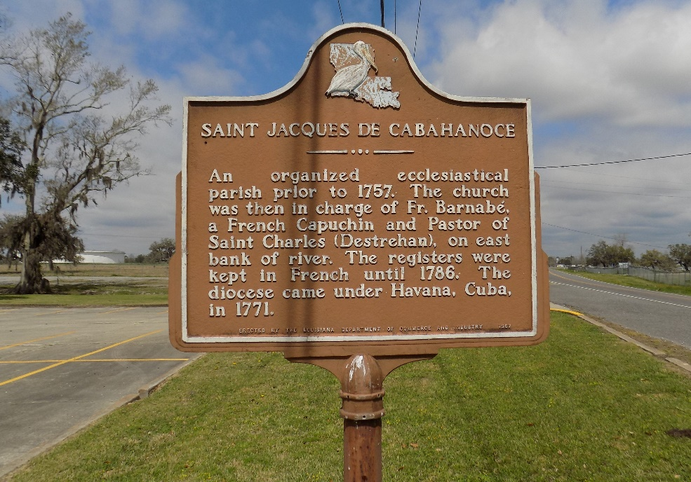

Joann was born in Welcome, LA on January 18, 1943, to the late Joseph Albert and Corrine Williams Albert. She was the 4th of four children and is preceded in death by siblings: Barbara Montgomery, Harriet Wheeler, and Frank Bourgeois. Joann passed on Friday, March 18, 2022, at The Crossing at Clarity Hospice.
She is survived by her loving husband of 60 years, David Joshua; her loving daughters: Marcia Joshua of Laplace, LA and Bonnie Joshua Haydel of St. James, LA; grandchildren: Myles Haydel of Atlanta, Georgia, Josef Bell of St. James, LA and Brooklyn Haydel of Baton Rouge, LA; 3 sisters-in-law: Eula Mae Murray and Beatrice Joshua of Donaldsonville, LA and Dollie Joshua of Kenner, LA; Brother-in-law: Sidney Joshua of New Orleans, LA, and a host of nieces, nephews, other relatives and friends.
She was preceded in death by daughter, Wanda Joshua and granddaughter, Tiah Brown.
A Funeral Mass of Christian Burial will be held on Saturday, March 26, 2022. Visitation 8am-10am. Mass @ 10am at St. James Catholic Church, 6613 LA Hwy. 18, St. James, LA. Interment: Church Cemetery.

The Times-Picayune, New Orleans, Louisiana
Mar. 25 to Mar. 26, 2022

