Harvey Joseph Lasseigne

June 2, 1922 – April 17, 2010

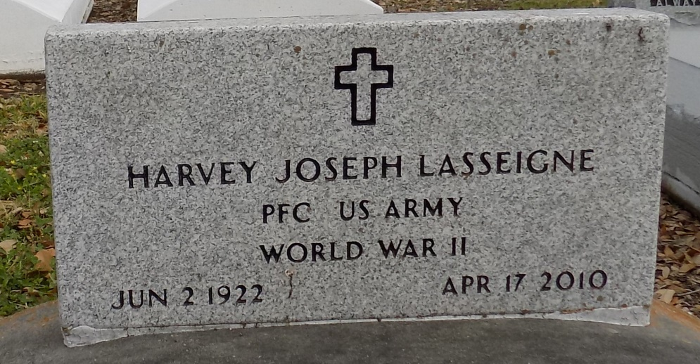

Harvey Joseph "Café" Lasseigne, 87, passed away on Saturday, April 17, 2010. He was a native and resident of St. James. He was a graduate of St. James High School and was a football player for the Wild Cats. He was drafted into the Army in the 11th grade in 1942. While serving in the Army he was a private first class. Harvey was a retired St. James Parish Deputy that he held for 20 ½ years. He was avid gardener, a huge LSU fan, and a member of St. James Catholic Church.

Harvey is survived by his wife Judith Patricia "Pat" Lasseigne; two daughters Judith and Amanda Lasseigne; and numerous nieces and nephews.

He is preceded in death by his parents Adam and Magda Guidry Lasseigne; four brothers James, Etienne "Bud", Leo and Arthur "Casey" Lasseigne; and four sisters Julia Buntin, Adine "Billie" Pisiana, Magda Hidalgo and Florence "Honey" Mabile.

Visitation at St. James Catholic Church, with Mass of Christian Burial.   
Interment will follow in church cemetery. Arrangements under the direction of Ourso Funeral Home (3541), Donaldsonville, LA.

Unknown source