Robert Samuel LeBeouf
1938 – February 24, 2001

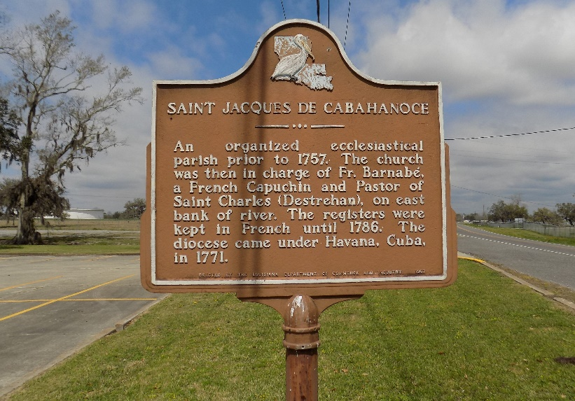

LeBOEUF NEW ORLEANS – Robert Samuel LeBoeuf, 62, a native of St. James and resident of New Orleans, died Feb. 24. He was the husband of Barbara Quezaire LeBoeuf and father of Charmaine and Troy LeBoeuf. He was also the son of Murry and Leah Folse LeBoeuf and brother of Ella Harleaux, Donnaleah Carstarphen, Catherine Moore and Elmo, Larry and Albert LeBoeuf. He is also survived by two grandchildren.
Services were March 2 at St. Maria Goretti Catholic Church, New Orleans, with interment at St. James Catholic Mausoleum, St. James.

L’Observateur, LaPlace, Louisiana
Saturday, March 3, 2001

