Marva Mae (Mitchell) LeBoeuf

November 14, 1942 – June 13, 2006

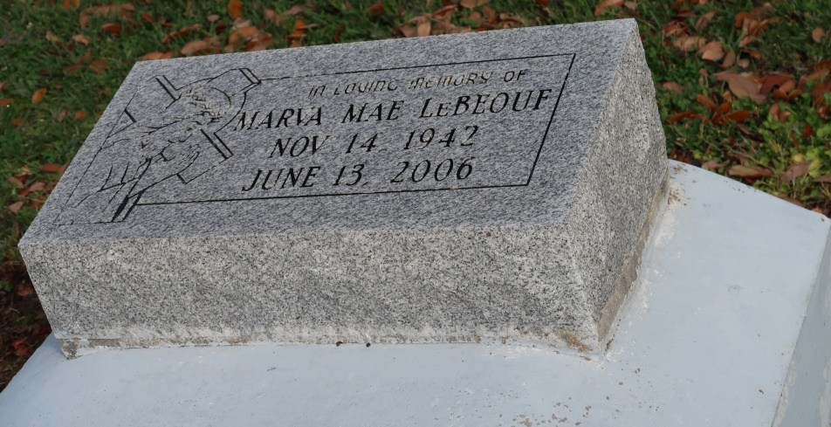

Marva LeBoeuf at Capital House nursing home in Baton Rouge, La., at 8:50 a.m. Tuesday, June 13, 2006.

Daughter of the late Ozeme Mitchell, Sr. and Albertha Moody Mitchell. Wife of Albert LeBeouf of Baton Rouge, mother Marvis Ann (Robert) LeBeouf, Vernon, and Albert (Mildred) LeBeouf, Jr. Sister and sister-in-law of Dorothy and Esmond Shepherd, Marie Lewis, Louise and Hubert Taylor, Alberta Mitchell, Peter and Lottie Mae Mitchell, James and Lorraine Mitchell, Paul and JoAnn Mitchell and Roy and Cynthia Mitchell, and the late Ozeme Mitchell, Jr. Sister-in-law of Eva Mae Harris, Willie Ann and Joyce LeBeouf, Octavia Thornton, Paul and Charles LeBeouf and the late Alice Ankum, Warren LeBeouf, Sr., and June LeBeouf, Jr. Daughter-in-law of the late Octavia and June LeBeouf, Sr. Also survived by 14 grandchildren and one great-grandchild, nieces, nephews, cousins, other relatives and friends. Age 63.

Visiting at St. James Catholic Church, St. James, La. Saturday, June 17, 2006 from 9:00 a.m. until Mass of Christian burial at 11:00 a.m. conducted by the Rev. Louis Oubre. Interment in church cemetery. Brazier-Watson Funeral Home in charge of arrangements.

The Times-Picayune, New Orleans, Louisiana

June 16, 2006