Marion Louise (Ambrose) Luke
February 26, 1937 - March 13, 2025

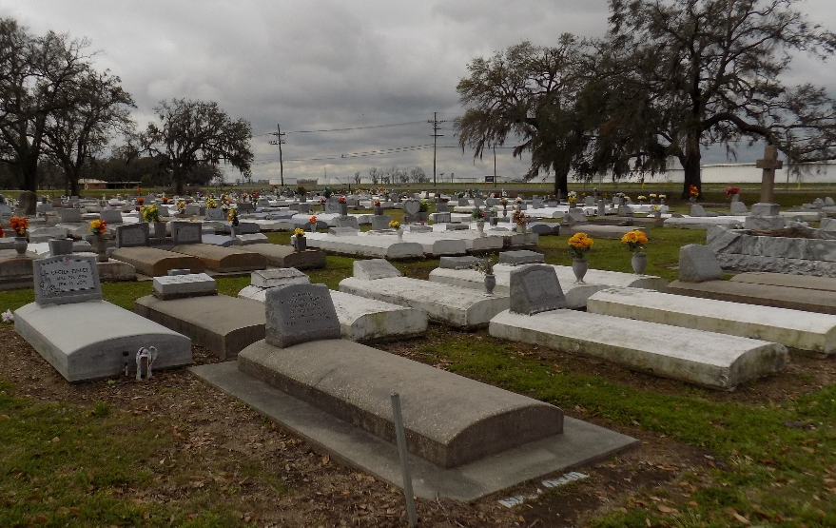

Marion Louise Ambrose Luke, 88, passed away peacefully at home in the arms of her daughter Alfreda on Thursday, March 13, 2025, in New Orleans, Louisiana. Born on February 26, 1937, Marion was the youngest child of the late Felecian Ambrose and Florence Saul Ambrose of Vacherie, Louisiana. She was the heart of a large and loving family. Marion was preceded in death by her siblings, (brothers) Andrew Ambrose, Titus Ambrose, Felecian Ambrose Jr. (sisters) Audry Oubre, Joan Bazile, Cecile Finley, Teresa Harry, Gladys Dumas, and Grace Costley. Marion married Andrew Jackson, a union that blessed her with two daughters. Following Andrew's passing, Marion remarried Wilfred L. Luke Jr., to this union she was blessed with one daughter and four sons were born. Marion was also preceded in death by her second husband, Wilfred, and her beloved son, Darryl Joseph Luke.
Marion leaves behind a devoted family who cherished her deeply. Children: Nathalie Marie Smith (New Orleans, LA), Mary Maureen Walker (Jeffery) (Los Angeles, CA), Wilfred Leonard Luke III (Tanya) (Vacherie, LA), Alfreda Louise Durham (New Orleans, LA), Norman John Luke Sr. (Michele) (Harvey, LA), and Derrick Mitchell Luke Sr. (San Bernardino, CA); 15 Grandchildren: Benjamin Raymond Johnson Jr. (Latundra); Jeremy Allen Masters (Kionna), Derrick Luke Jr. , Paige Elizabeth Luke, (New Orleans, LA); Andrew Stonewall Johnson (Renauda) (Dallas, Tx); Amanda Luke (Tacoma, WA); Norman John Luke Jr.(Simone), Nicole Cecilia Luke, Daniel Mitchell Brumfield (Harvey, LA); Janaye Walker Graver (Kevin)(New York, NY); Asha Walker Manolius (Jack) (Los Angeles, CA); Brittany White, Alexis Luke, Wilfred L. Luke IV (Moreno Valley, CA) and Derriana Luke (San Bernardino, CA); 9 Great Grandchildren: Tiffany Johnson, Benjamin Johnson III, Aaron AndrewGreen, Isabella Johnson, Naraiya Johnson, Reniya Johnson, Aiden Walker-Manolius, Avery Walker Graver, and Paisley Luke. A beloved mother, grandmother, great-grandmother, mother-in-law, sister, aunt, and friend, Marion touched the lives of many with her kindness, warmth, and unwavering love. A proud and dedicated member of St. Jude Catholic Church in New Orleans, Marion’s faith and compassion guided her through a remarkable life of service. As a working mother, Marion devoted more than 25 years to the Archdiocese of New Orleans, serving as a preschool teacher at St. Phillips Preschool Center. She was affectionately known as “Ms. Luke” in the Desire community, a highly respected and beloved figure to children and families alike. Following her retirement, Marion embarked on a new journey, earning her Licensed Practical Nursing certification. She brought care and comfort to her patients, touching lives with her nurturing spirit and gift for conversation. Marion also found joy in exploring the world, often traveling with her sisters and nieces on cruises or visiting her children across the country. Her greatest happiness, however, was found in the embrace of her family, who adored her dearly. "If we live, we live for the Lord; and if we die, we die for the Lord. So, whether we live or die, we belong to the Lord." - Romans 14:8 A Mass of Christian Burial will be held on Saturday April 5, 2025 at St. James Catholic Church, 6613 LA-18, St. James, LA 70086 with visitation beginning for 8:30 am and Mass to follow for 10:30am. Interment St. James Catholic Church Cemetery. Treasures of Life Funeral Services, Gramercy, Louisiana
April 6, 2025

