Florence (Clement) Matherne

March 3, 1938 – April 2, 2017

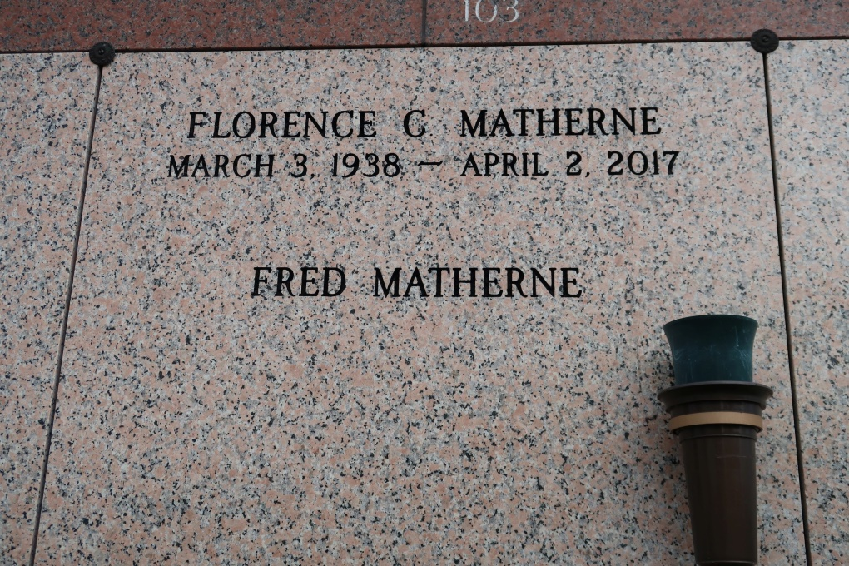

Florence Clement Matherne, 79, was born on March 3, 1938 and passed away on April 2, 2017. She was a native of Thibodaux, LA and a resident of Saint James, LA.  
 A visitation will be held on Saturday, April 8, 2017 at St. James Catholic Church from 9:00 AM until a Mass of Christian Burial at 11:00 AM. Interment will follow in the church cemetery.  
 She is survived by her husband, Fred Matherne; sons, Kerry and wife Wendy, Joel and wife Constance, and Jeff and wife Dawn; grandchildren, Derek Matherne, Natalie Matherne, Angelica Lee, Milre Matherne; great-grandson, Parker Matherne; brothers, Jerry Clement, Charles Becnel Jr., Louis Becnel, George Clement, and Thomas Clement, and sisters, Linda Thibodaux and Betty Allemand.  
 She is preceded in death by her parents, Claude and Alcidie Rose Clement; adoptive parents, Charles and Inez Clement Becnel Sr.; brothers, Lloyd Clement and Edward Clement; and sisters, Mildred Ockmond and Nell Clement.  
 Thibodaux Funeral Home, Inc. is entrusted with handling the funeral arrangements and online condolences.

Thibodaux Funeral Home, LaFourche Parish, Louisiana