Thomas Mayho III

March 25, 1935 – June 3, 2008

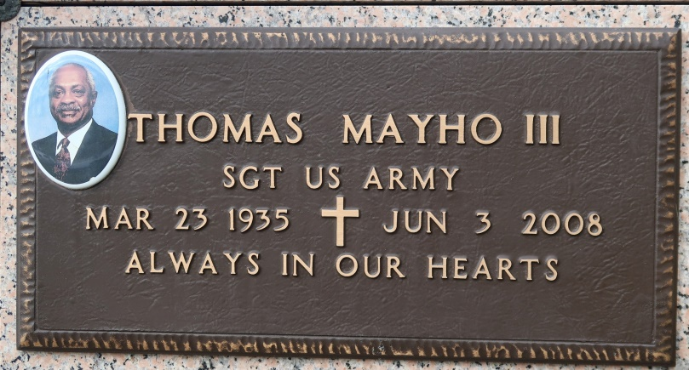

A retired employee of Southern California Gas Co. in Los Angeles, he died at 8:45 p.m. Tuesday, June 3, 2008, in Baton Rouge. He was 73, a resident of Baton Rouge and a native of New Orleans. He was a U.S. Army veteran, having served as a paratrooper with the 101st Airborne Division.

Visiting at Highway Baptist Church, 1185 Magnolia Heights, Vacherie, on Saturday, June 7, from 9 a.m. until religious service at 11 a.m., conducted by the Rev. Isaiah J. Webster, pastor of Greater New Guide Baptist Church in Baton Rouge. Entombment in St. James Catholic Church Mausoleum, St. James.

Survived by his wife, Inez W. Mayho; father, Thomas Mayho Jr.; three daughters, Pamela Dupard, Marilyn Myles and Elizabeth Watts; three sons, Ronald A., Thomas IV and Daryl J. Mayho; a sister, Joan Miller; two brothers, Lester Mayho and John Allen; 19 grandchildren and three great-grandchildren.

Preceded in death by his mother, Elizabeth Allen; grandparents, the Rev. Thomas Mayho Sr. and Felonise Mayho; mother-in-law, Mable Edwards; father-in-law, Romalice Williams Sr.; sister and brother-in-law, Lucille Batiste and Roy Christoff. Arrangements by Demby & Son Funeral Home, Donaldsonville.

The Advocate, Baton Rouge, Louisiana

June 6, 2008